**Subject: Only STUPID florists will ignore this…**

My name's Nigel Botterill. Over the last eight years I've built, from scratch, eight separate million pound plus businesses.

I've just finished writing a report specifically for Printers...

Click HERE to download it.

...it includes the 7 big things that all Printers who want to be super successful in business need to do, and you can get your hands on it completely FREE. It's called:

**'The 7 Things You Can Do To Make A Step Change in your florist business TOMORROW'**

**CLICK HERE** to download my free florist report

It contains the 7 most valuable techniques and strategies that I've used to build eight separate million pound plus companies in just eight years.

**The BAD NEWS:**

Here's the bad news though, I can only keep this download active for the next week, and after then I'll be taking it down, so don't hang about!

**CLICK HERE** to download it right now

This just might be the kick start that you've been looking for.

Whether you need to:

* Boost your **turnover**...
* Work less and **earn more**...
* Spend **more time** with your family...
* Or you're working towards a formidable goal...
* ...this report will be **exactly what you're looking for**.

Talk soon,

Nige

**Subject: Your florist success report download**

Hi {firstname}

Yesterday I gave you the chance to download my brand new seven step report AND get it mailed right to you at MY expense.

It’s called **'The 7 Things You Can Do To Make A Step Change in your florist business TOMORROW'**

I've had some great feedback overnight, and I just wanted to be sure that you managed to download it {firstname}?

If you have, I’d love to know what your biggest lesson was. What did you take from it? Hit REPLY and let me know…

Speak soon

Nige

P.S. If you missed my email yesterday, you can still get your hands on my florist business report, just **CLICK HERE TO DOWNLOAD IT** (it’s completely free, no strings attached…)

P.P.S. The report is packed full of the techniques and strategies I’ve used to build eight separate million pound plus businesses over the last eight years – I know they’ll be hugely relevant to your florist business. The page is still live, so CLICK HERE to grab your copy before it’s too late!

**Subject: The #1 most important thing for florists…**

Hi {firstname},

I hope you took some useful ‘nuggets’ from my 7 Step report for florists.

I’ve had a whole “bunch” of great feedback from florists just like you, and loads of that feedback has been about one bit of advice in particular…

…that advice? **Follow up, follow up, follow up!**

It’s so, SO important that you follow up on every single conversation you have with prospective customers. **CLICK HERE** to watch a short video I filmed on the most effective way you can change your follow up process to grow your business:

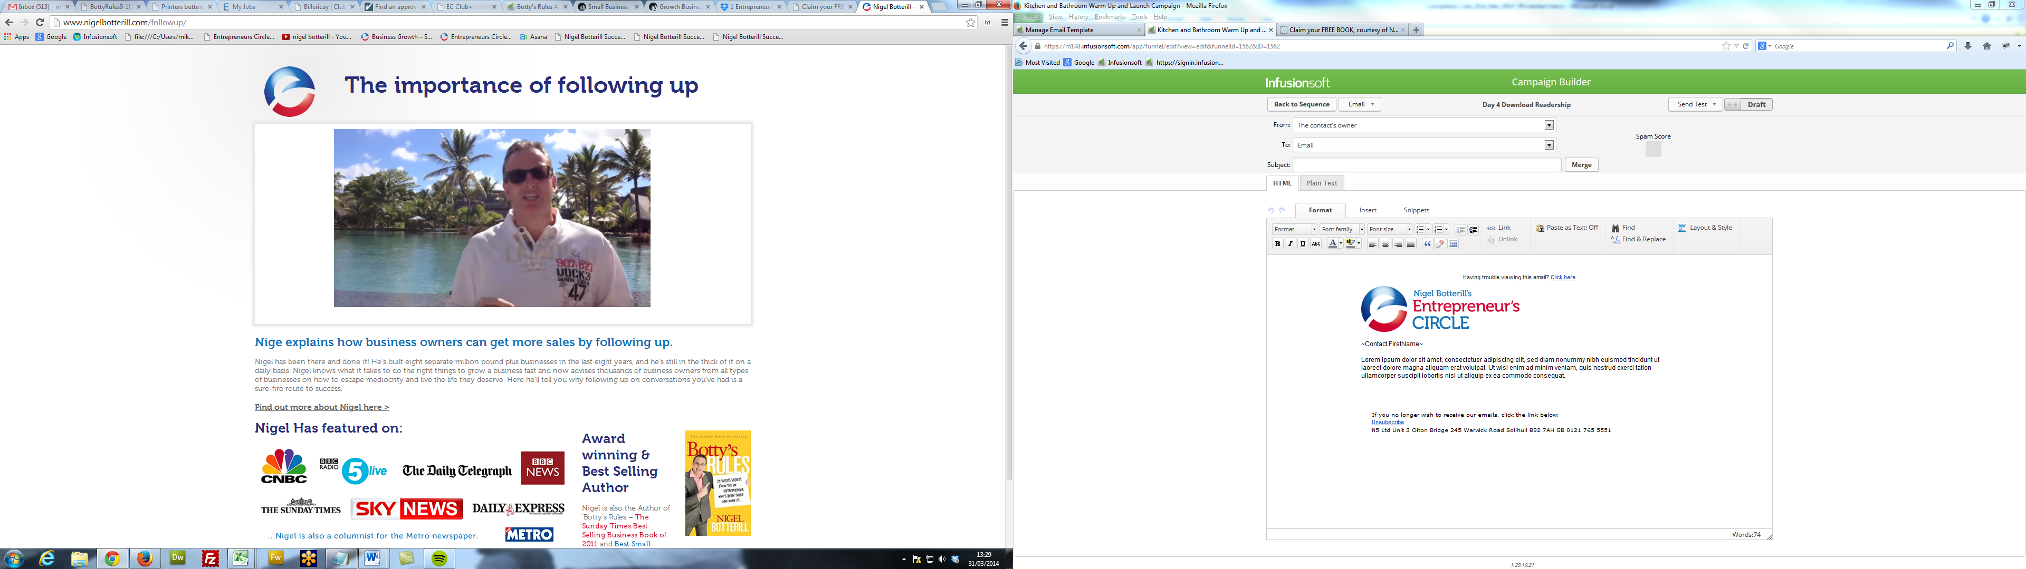

**CLICK HERE to watch the video,** it’s only a few minutes long.

Fire me a line back to let me know what you think.

Speak soon,

Nigel

P.S. If you’d like to discover the other 6 nuggets are, then download my whole report (**'The 7 Things You Can Do To Make A Step Change in your florist business TOMORROW').**

**CLICK HERE to either** download it immediately or get a lovely printed copy mailed directly to you completely FREE.

**Subject: ZIPWIRE!**

Here's a two minute video where I'll share with you a GUARANTEED way of getting new customers in literally 30 minutes. It's simple...

{INSERT VIDEO HERE}

Just click HERE to watch the video.

Nige “Danger” Botterill

P.S. The Zipwire isn't compulsory!

**Subject: Taking a Leaf out of Apple’s Book**

I bought another iPad last month.

Once I’d made the decision that the only thing missing from my life was *another* shiny new tablet computer (which is a whole article in itself!) I swung by the Apple store in Solihull to pick one up. It turns out that buying an iPad just isn’t that simple...

Even though I was in the store, with my credit card at the ready, all sweaty-palmed about the prospect of getting my hands on an oversized iPhone, I left the store with nothing.

*They hadn’t got any in stock.*

The staff were really nice about it. They explained to me gently that lots of people want iPads, and that means inevitable shortages as the company struggles to meet demand.

**CLICK HERE** to read the full story…

[THIS NEXT BIT GOES ONLINE]

They walked me through the process of pre-ordering an iPad on one of the many display machines, explaining that I’d get an email when my iPad was ready for collection.

Sure enough, two days later I had an email from Apple, saying that my iPad was instore, and ready for collection. I had until store-closing time the following day to pick it up.

Well, I shot down there, running breathlessly into the store, finding the nearest assistant, and saying “I’ve had the email, my new iPad’s ready for collection”. The assistant congratulated me on my purchase and toddled off to the storeroom.

He soon came back with my iPad and quickly explained that I’d probably want some sort of protective cover for my lovely new shiny thing and showed me the range of cases. I opted for the cheapest, a steal at £30.

As you can see, buying the iPad wasn’t as easy as picking up the milk, but it could be, so it’s worth looking again at the buying process and breaking it down...

**Out of Stock?!**

You can usually pick whatever you want to buy, whenever you like. Not the iPad. Apple has created the illusion that there’s a shortage, a waiting list. This increases desire and creates an air of exclusivity.

**Shop Experience**

Of course, while I was in the Apple store trying to buy my iPad, the whole product range is staring me in the face. If you’ve ever been in an Apple store, you’ll know that they are designed to allow you to touch, play with and interact with every one of their products. You're invited to pick up an iPod or Macbook and just play with it.

**The Collection**

I was sent an email telling me that I could collect my iPad, but I only had 30 hours or so to get it. The tight deadline here doesn’t leave much time for procrastination. The inference was that that was the absolute longest they could hold it for, before the storeroom door finally gave-in to the throng of would-be buyers.

Of course, on collection, the shop assistant (the “Genius”, in Apple-speak) actually CONGRATULATED me on my purchase. Like I’d won a prize, or an award for ‘smartest shopper’ or something.

You don’t need me to tell you that this is a really smart strategy (but I just have anyway, to be sure that you highlighted it, or wrote it down or something).

**The Upsell**

Before I’d paid for my iPad, my ‘Genius’ had taken me to a beautiful display of covers and cases, and made the easiest upsell in the history of time; “of course, you’ll want something to protect that beautiful thing from scratches”. I’ll bet that at least 75% if iPad buyers take the upsell and spend another £30-£50 on a case, ontop of the £400+ cost of their new iPad.

I don’t believe that any of this happened by accident. Apple sold 2 million iPads in the first 60 days of sale. They know what works.

**Three Apple Strategies You Should Apply to Your Business**

1. **Focus on the Customer Experience**

If every other business in the market are doing one thing, it takes a brave business owner to do something else, but that’s exactly what Apple do. Where most software companies (like Microsoft) jump into bed with any hardware manufacturer, Apple design and control their own hardware. That’s why everything they do looks and feels completely different to anything else available.

Hardware and software are industry demarcations that buyers couldn’t care less about. By focusing on creating a great customer experience from start to finish Apple effectively exploded the portable music player market with the launch of the iPod (nobody talks about an MP3 player; iPod has become a synonym), with the iPad, Apple have created a massive market that simply didn’t exist before.

1. **Keep it Simple: Less really is more.**

Take a look at the Apple homepage, notice how it’s completely lacking visual clutter? You’ll see exactly the same thing going on in all of Apple's interfaces. That clean, minimalist look. There isn’t a power button on a iPod, there aren’t number keys on an iPhone. Everything’s there, but it's hidden away.

Consumers find this attractive, *less*features and *less*controls appeal to more people. It’s the same in business. The easier that you can make life for your buyers, the more likely they are buy. This counts for both the buying process (don’t make them jump through unnecessary hoops) AND your product or service. Do you offer a completely ‘done for you’ service?

1. **Make sure people are getting value**

Perhaps because most Apple products are SO different from their PC-based counterparts, Apple seems to be particularly good at providing the support and help new customers need to get to grips with their new purchase. With every purchase they offer ‘One to One’ personal support for 12 months, it’s a neat upsell at £79, but more importantly, it helps new customers to make the transition from PC to Mac, so they won’t just give up at the first hurdle.

The One to One package includes transferring your files from your old computer, installing your new software and making sure everything’s set up the way you want it. It also includes personal training sessions in Apple stores as well as loads of web-based training.

Even if you don’t take this option, you can still walk into any Apple store and ask a ‘Genius’ for help with anything. In my experience, they are all super-nice and falling over themselves to help you out.

This may sound like an Apple sales-pitch, but there’s a real lesson here:

**If your customers aren’t getting good value from your product or service then they’re not going to buy from you again, or recommend you to their friends and colleagues.**

Apple go out of their way to make sure that you actually get their machine out of the box, turn it on and start using it. They don’t just want to flog you a box and pocket the profit. They want to turn you into a raving fan, telling everyone what a great new computer/iPad/iPhone you’ve bought and how it’s changed your life.

How can you apply these 3 Apple strategies in your business?

**Subject: 300 New Prospects in 2 Days!!**

Last weekend, one of my team pulled off a fairly incredible marketing feat.

Armed with a budget of just £100, he pulled in 329 new prospects in less than 48 hours!

**He did it all through the power of Facebook…**

I’ve just recorded a short video on how he did it AND I’ll share with you a sneaky way of knowing if Facebook is for you or not.

Click the play button to watch.

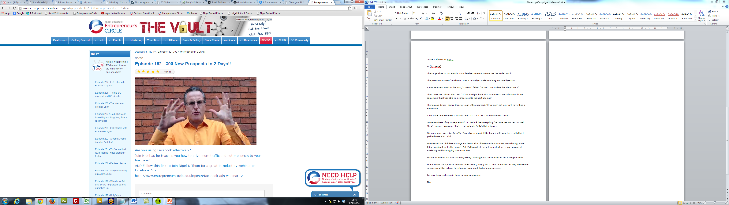

Enjoy the video…

Speak soon

Nige

**Subject: Good news Mike!**

We’ve got a few hundred over-prints of recent Entrepreneur’s Circulars (our monthly business building magazine), and we’d like to send you a copy, absolutely free.

**CLICK HERE** to get yours.

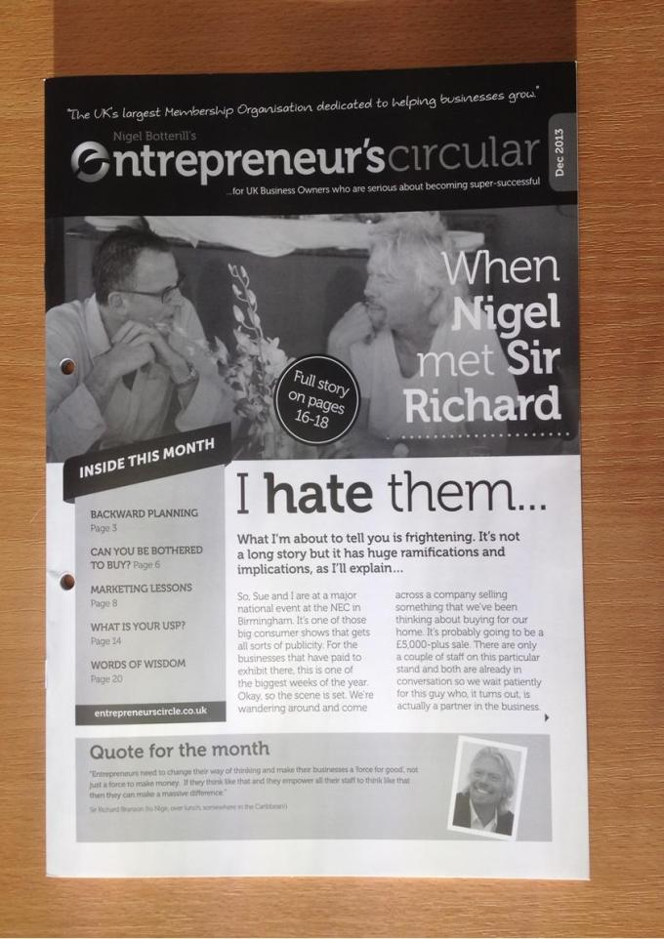

The Entrepreneur's Circular is often described as a seminar in an envelope. Packed full of useful and practical 'nuggets' of information, it really is a must read for any UK business owner.

Devoid of all bullshit, statements of the obvious, and things you already knew (!) the Entrepreneur’s Circular is a complete breath of fresh air for hard-working business owners.

**CLICK HERE** to get your FREE copy in the post.

Normally, it's only available to members of the Entrepreneur's Circle *(UK business owners who are paying thousands of pounds a year for advice from me and my team of experts),* but for this week only, I’m making some past copies available to non-members.

If you want to get your hands on one, **CLICK HERE**, drop your address in the box and we'll get one out to you absolutely FREE of charge.

I’m expecting these Circulars to be gone within the next couple of hours, and I’ve got no more once they’re gone – hang around and you’ll miss out. Take action now and **CLICK HERE** to request your copy.

Once they’re gone, they’re gone.

Speak soon

Nige

**Subject: Just hardnosed useful stuff...**

Okay, something practical for you now. No psychobabble - just hardnosed, useful stuff that you can implement. Today.

Every business has previous customers who they haven't spoken to in a while.

Sending out an email or a postcard or a letter to those customers THIS WEEK will result in some sales for you. These will be sales that you would otherwise not get.

**You won't get any extra sales unless you take action  
 and send something to those “lost” customers.**

You can say something along the lines of:

*"It's been a few months since we saw you/you bought from us/we had the chance to do work for you and we miss you.*

*Seriously, it's been too long. We'd love to help you/serve you/supply you and if you give us a chance we'll do something really special so you won't forget us again!*

*Hope everything is okay with you, but it will be great to see you/talk to you soon. Give us a ring and let me know how we can help."*

Of course, you'll make it better. You'll do it in your words but it won't take much. It shouldn't be a hugely overt sell - just let them know that you miss them and you'd like to serve them again and watch what happens.

Send something. Let me know what happens…

Nige

**Subject: The worst piece of marketing…. EVER!**

Hi {firstname},

What I am about to unveil is the worst piece of marketing you’ve EVER seen!

Whatever you do – DO NOT make this mistake in your business.

I can imagine the hours and hours of design work that have gone into this and the thousands of copies that have been printed and posted out.

There’s no doubt that thousands of pounds have been spent on this and hours of man time ploughed into it.

So how can this be the worst marketing piece you’ve ever seen?

Click the video to watch…

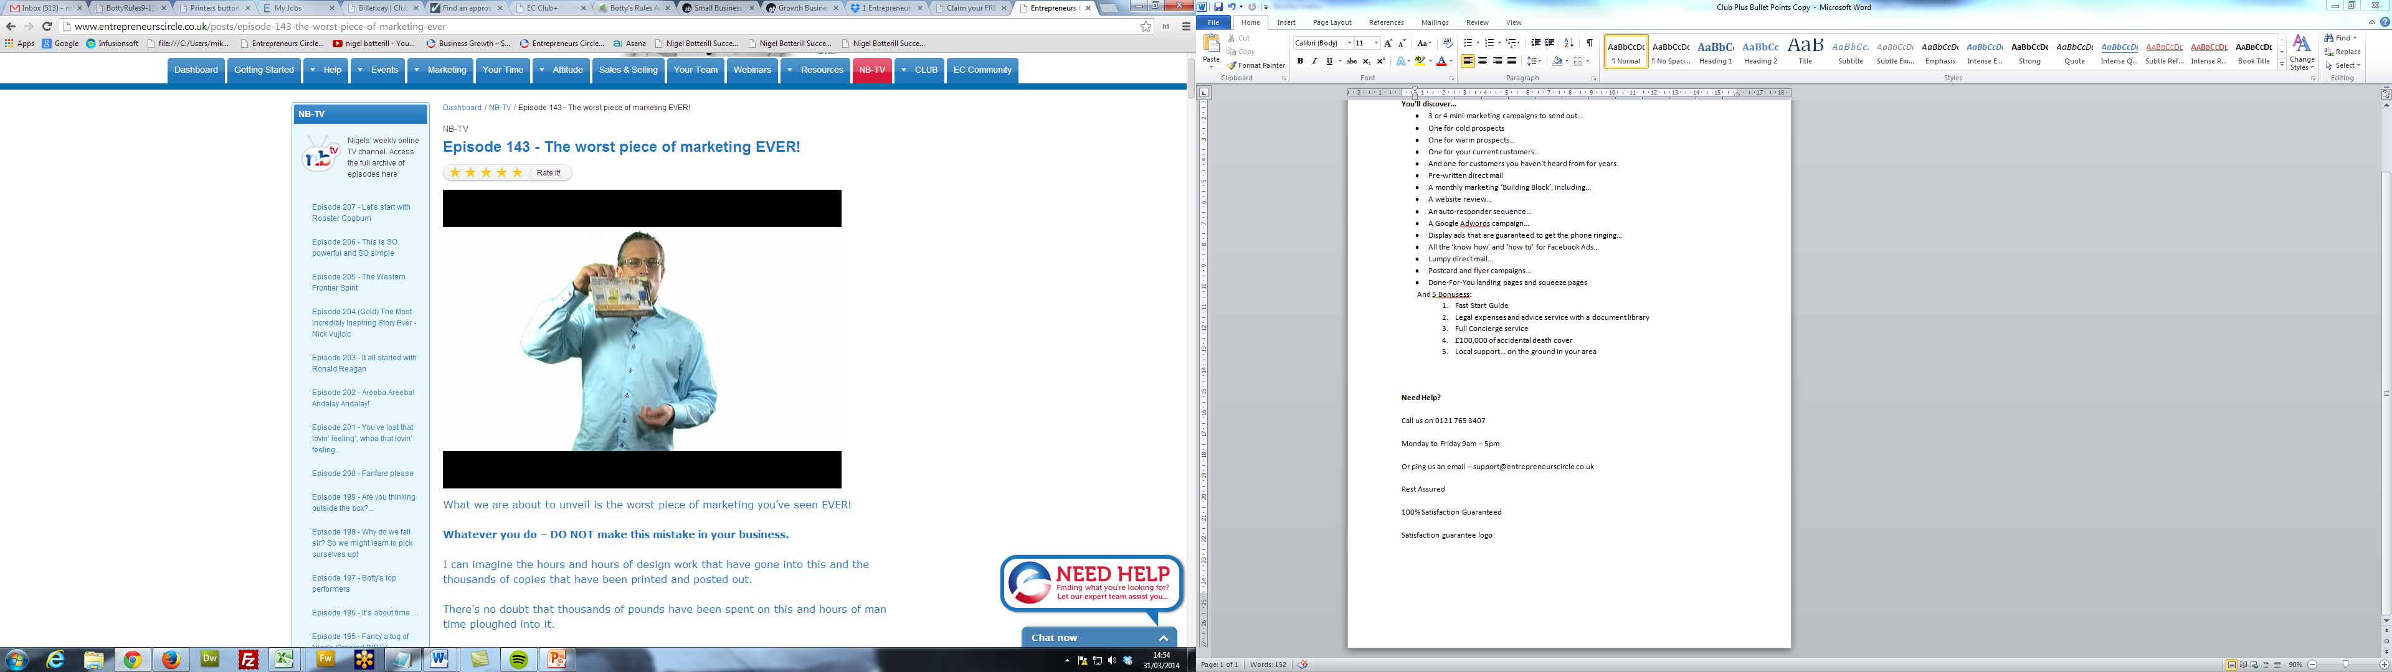

Speak soon

Nige

Subject: Something exciting is on its way…

Hi {firstname},

I hope you’ve got some use out of what I’ve sent to you over the last week or so. To reach super success in business it’s important you know where you’re going.

And that’s why you need a **purpose** or a **goal**. My goal is to help UK small businesses to grow by a combined £1,000,000,000 (that’s a billion pounds!) in 2014.

Keep an eye on your inbox over the next couple of days. I’ve just finished working on a brand new video which is now on the cutting room floor, and I truly believe that what I have to share with you solves the biggest problem for 98% of XXXX.

Remember to keep an eye out…

Nigel

P.S. What’s your goal? It should be big, intimidating, hairy, and make you feel a little queezy. Then go for it!

Subject: Tomorrow at 9am…

Hi {firstname}

It’s nearly time! Tomorrow at nine o’clock I’ll be sending you the video that I’ve been working on over the last couple of weeks.

I’ve filmed it specifically for XXXX like you, and it solves the biggest problem for 98% of XXXX.

I’ve shown it to a couple of XXXX already, and I was blown away by their feedback… It’s been quite phenomenal!

So make sure to keep an eye on your inbox tomorrow at 9am for my email. It’ll have the subject line [VID] Important Video For All XXXX.

Set a couple of minutes aside to take a look at what I have to share with you….

Have a productive and prosperous day,

Nigel.