**It’s your Age! Or is it?**

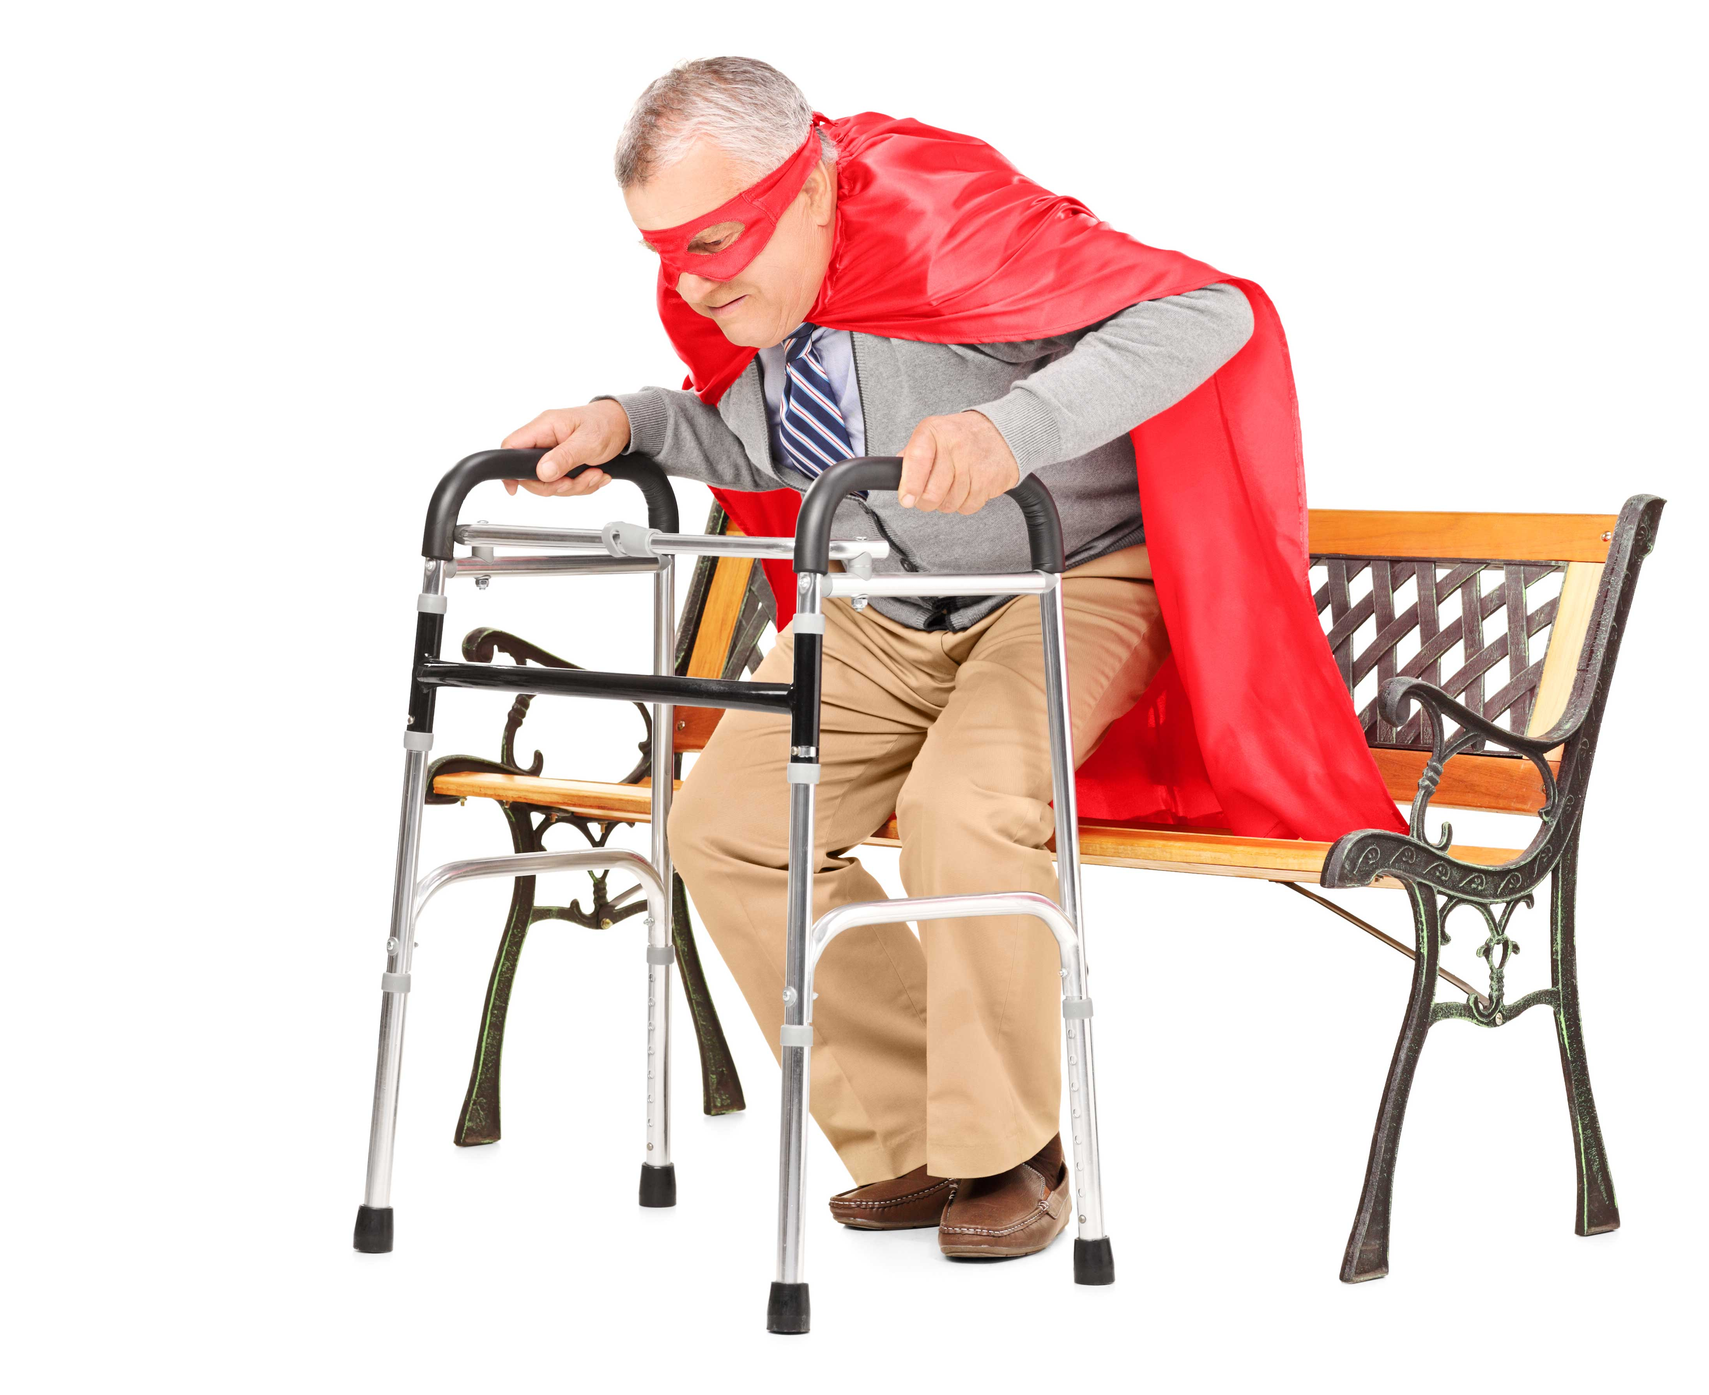

Have you ever had an ache and been told by friends and family “It’s your age, you’ve just got to put up with it”?

Or “There’s nothing we can do, it’s age-related”?

Just this week a patient told me he was just old, and asked what should he expect at his age.

Well, there are somethings that can’t be stopped or reversed, but some aches and pains are unnecessary.

So how do you know the difference?

Usually arthritic pain starts gradually, it’s bothersome at the start, but not agony. It starts when some of the cartilage covering the ends of the bones roughens and becomes thin, then the bone thickens. So the pain is not sudden.

As time goes on (we’re talking months and years here, not days) the bone at the edges of the joint thicken and form bumpy bits called spurs or osteophytes. That’s why arthritic joints look a bit fatter than normal.

Of course as all of this wear and tear happens it can cause pain, but it also causes a change in the way the joint works, which means the muscles can get tight, and the joints above and below have different strains put on them.

So, not only does the arthritic joint hurt, you’ve now also got pain from the changes in the muscles and other joints. And these can be helped with treatment. Muscle strains and joint pains can be treated with osteopathy, and we can give you easy things to do at home to help keep the area mobile. You’d be amazed at how many patients think their pain is caused by arthritis when it’s only a muscle strain.

So, don’t sit there and blame your age – get the right exercises and treatment. You don’t have to put up with it!