

**Broadcast**

**Summary**

*Caution: These notes should be used in conjunction with the recorded interview. While every effort is made to ensure accuracy, APM cannot guarantee freedom from any errors. Treatment should be based on the advice given by the expert speaker during the interview. Please let us know if you find any errors in this text so that we can correct them.*

**The Effect of Physiological Load**

With Matt Wallden

**About Matt Wallden**

* Trained as an Osteopath and Naturopath in the 1990s. Worked in professional sports by 2003.
* Completed a BSc(Hons) and a Masters in Osteopathic Medicine before proceeding to train in the CHEK System between 2001-2005.
* Bought an early version of the Vibram Fivefingers in 2006 and was the person who explained to Vibram that their “sailing shoe” had applications in rehabilitation and conditioning.
* Contributed several chapters to various medical texts and has been an Associate Editor of the Journal of Bodywork and Movement Therapies since 2009.
* Presented here and abroad to post-graduate, undergraduate and various medical groups and has been a part of the CHEK Faculty since 2006.
* Authored a chapter on Rehabilitation in the 2008 book “Naturopathic Physical Medicine”
* [www.mattwalden.com](http://www.mattwalden.com)

**Physiological/allostatic load**

* Allostatic load or physiological load is the long-term effect of continued exposure to chronic stress on the body.

**Paul Chek**

* Founded the Chek Institute and devised the term ‘physiological load’.
* Specialises in holistic and congruent exercise rehabilitation, nutrition and emotions, and the importance of viscera in exercise and muscle function, etc.
* It drives central sensitisation and central sensitivity. The process of central sensitisation relates to stressors in the system which lead to the nervous system becoming hypersensitive.
* Physiological load can also lead to the development of degenerative, neurological conditions (E.g. *Overall stress in the system takes individuals to fight-flight state and less of a rest-digest state which then negatively affects their blood sugar mechanisms. The latter, when suboptimal, can lead on to Alzheimer’s and other neurological degeneration*).

***Central sensitisation***

* Central sensitisation is the more modern interpretation of ‘facilitated segment’. The terminology was changed because technically when something is inhibited it is not one segment but multiple segments that are compromised spanning up and down several joints (E.g. Colon is innovated by T12, L1, L2 and several segments up and down the cord).
* It is not just about physical pain. It could be manifested in irritable bowel syndrome, and post-traumatic stress disorder (emotional pain). These syndromes make people lose a lot of fine motor control.
* People who fatigue early are more prone to injury.

|  |  |
| --- | --- |
| *The illustration above shows that physiological/allostatic load precedes central sensitivity and the latter precedes persistent pain.* | * There is a link between cardiovascular markers and arm injury. And patients who suffer a heart attack may get pain in the arm. * High levels of cardiovascular markers indicate that there is stress on the heart which then increases the risk of getting tennis elbow seven times and risk of getting carpal tunnel syndrome five times. * Patients with high levels of cardiovascular markers are more likely to get Achilles issues. |

**Tools for physiological load assessment**

* The heart rate variability system measures the variations between consecutive heartbeats. This is popularly used among athletes these days.
* The Health Appraisal Questionnaire was designed by a team of medical doctors to asses different aspects of the human physiology. It screens 28 different organ and glandular systems that allow people to see their overall physiological load and identify which organs are under stress.
* The questionnaire was calculated and weighted so that it has good clinical relevance. The questionnaire was adjusted/polished based on the results of the lab tests done for different aspects of human physiology.
* It allows clinicians to tailor their advice to their patients before they come for a check-up. The questionnaire can be sent out to the patients before their clinic appointment.
* The idea of the questionnaire is to determine those categories with a high score so then people will know which laboratory test/s to do.
* It takes 20-30 minutes to answer the questionnaire because it is comprehensive. It saves patients on consultation time.
* One way to get a sense of what the patients are looking for and how that matches up with what the clinician offers is to ask them to rate on a scale of 0 to 10, how the following factors may impact them to get better: financial stress, time stress, and energy stress.
* The results of the appraisal questionnaire can significantly inform the practitioner’s clinical findings and advice i.e. factors related to nutrition and lifestyle that can address those physiological stresses.

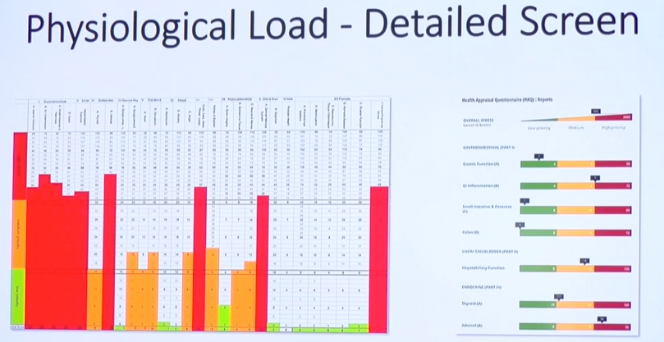

*The figure above is a sample report based on the Health Appraisal Questionnaire that shows where the high stress is and what the total stress is.*

*The red on the left side indicates that the gastrointestinal system including the liver and gallbladder are under stress. Other findings include progesterone decline symptoms (not much of a concern for a woman in her 40s-50s but for a lady in her 20s-30s this could be indicative of nutritional deficiency as a result of gut issues - parasites or fungus).*

*On the right side, the overall stress score indicating a high physiological load is shown at the top and the bars below it tell which different systems all that stresses are coming from. This system is available at www.mattwallden.com for £8.99. Rather than paying the clinician’s hourly rates, patients can opt to access it online and they get the results back after filling in the questionnaire. They can either take the results to their osteopath or chiropractor for further advice.*

**Nutrition, diet, and gut**

* One of the key ways to decrease physiological load is to work with nutrition.
* With literature and marketing, the emphasis has been around taking energy-based drinks and energy bars and not necessarily on the nutrition to repair and replace damaged tissues. This is why poor nutrition is very common in high-performance sports.
* At all levels of high-performance sports, there was an over-focus on the notion that food is an energy source (i.e. high-carb, sugar-loaded, no greens, less meat) and less focus on repair and overall health.
* Wrong diet plus training, especially among endurance athletes, can create significant stress to their hormonal and digestive systems. This takes them into fight-flight state meaning they are not in a rest and digest state. The food tends to ferment in their gut which causes the increased likelihood of parasite/yeast overgrowth.
* When people’s digestion is impacted their ability to get nutrition on board is compromised.
* Eighty per cent of the immune system lines the digestive tracts. Other organisms enter into the gut, the latter makes them a part of the person’s system. This is why a strong immune presence is crucial.
* The immune system will get sensitised or overburdened with foods that are taken repetitively. The gut will create resistance such that when people take allergy test or immune sensitivity test, they are most likely intolerant to those food/s that they eat repetitively.
* When the digestive system is under stress, it typically impacts on the abdominal wall function i.e. the tonic fibres in the abdominal wall can be inhibited by viscerosomatic reflexes. This is part of what drives bloating in irritable bowel syndrome or premenstrual syndrome.

***Parasites in the gut***

* Laboratories test stools for the 3-4 main parasites that people tend to get and not for the hundred other parasites that are subclinical, but when combined can cause a problem.
* There are types of parasites that respond to antibiotics. Holistic dentists are allowed to prescribe antibiotics based on the laboratory test result.
* Black walnut tincture is potent at killing different types of gut parasites.
* There are effective natural substances (may not be as effective as antibiotics) in killing gut parasites with 60-70% potency such as ginger, garlic, Berberine, Pau D-Arco tea. Combining them is quite an effective approach.

**Other relevant notes**

* Jeffrey Bland, the forefather of functional medicine, emphasised that medicine is excellent at dealing with a horizontal disease (ie patient is horizontal - heart attack, traumatic injury), but terrible at dealing with a vertical disease (ie patient still standing – cancer, heart disease, Type II diabetes).