**Women’s Heart Attacks**

I've been ranting about this for years, and (as always) I blame Facebook.  You've probably seen it yourself - every so often it will raise its ugly little head again:  Someone on Facebook will re-post an article claiming that women have different heart attack symptoms to men.

NO THEY DON'T!

It's possible that the prevalence of some symptoms may be higher or lower among women, but that doesn't help at all.  What are you going to do - ignore possible signs of a potentially fatal condition just because a woman is less likely to experience them?  Duh!

The most common symptom is chest pain - usually quite central, but it can radiate to the arms (yes, both of them in some cases) and to the jaw.  It can also be in the lower back.  But it won't be a pinpoint pain - it will feel a bit like nasty indigestion, or could be crushing, squeezing sensation.

Someone having a heart attack  might feel sick.  They might be pale and clammy.  They could be short of breath.

They're very likely to be extremely anxious - the body generally realises when something really bad is happening, even if it doesn't know what.

If you think someone is having a heart attack, sit them down on the floor against a wall or a heavy object, knees bent, feet resting on the floor.  Ideally, use something to support the legs.

This is the position which places least strain on the heart and lungs.  What's more, if they become unconscious, they don't have far to fall.

Call 999 straight away - this person needs advanced medical care!  Don't worry that you may have got it wrong - better that than a dead casualty.

And here's another important fact:  many heart attacks are "silent".  That is, there are no obvious symptoms at all.  So if you're at all unsure, call an ambulance.

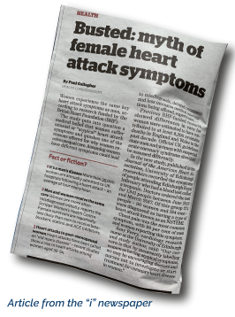

And don't ignore a possible heart attack just because it's a woman!

**Images**:

1. Article from “i” Newspaper, 21 August 2019

<https://inews.co.uk/news/health/british-heart-foundation-study-women-same-symptoms-men/>



1. Woman sitting

iStock photo. Photo ID: 512205622

**Reference**:

<https://www.bhf.org.uk/informationsupport/conditions/heart-attack/women-and-heart-attacks>