**The Shoulder: Simple Things Work- Resources**

**Free Assessment Videos:**

You have to put in your name and email but the videos are free

<https://clinicaledge.lpages.co/leadbox/145dd0173f72a2%3A11cdbb9c8b46dc/5766239481757696>

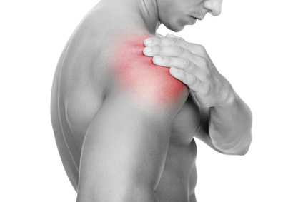**Cuff assessment in prone:**

https://www.dropbox.com/s/lkd2llk9flvin13/1.%20Prone%20cuff%20assessment%20posterior%20cuff.mp4?dl=0

**Shoulder Exercises:**

<http://www.liverpoolshoulderclinic.com/videos/>

**Isolated cuff exercise**

<https://www.dropbox.com/s/045hppe864apdos/3.%20Supported%20isolated%20posterior%20cuff%201.mp4?dl=0>

**Techniques**

**Stiff shoulder**

[**https://www.dropbox.com/s/p0trewc181fufbq/1.%20Mobilisation%20external%20rotation%20in%20neutral.mp4?dl=0**](https://www.dropbox.com/s/p0trewc181fufbq/1.%20Mobilisation%20external%20rotation%20in%20neutral.mp4?dl=0)

**Cervical Lateral Glide**

[**https://www.dropbox.com/s/tqf4ydpnw7tq6bc/1.%20Cervical%20lateral%20glide%20%281%29.mp4?dl=0**](https://www.dropbox.com/s/tqf4ydpnw7tq6bc/1.%20Cervical%20lateral%20glide%20%281%29.mp4?dl=0)

**Podcasts**

**Sporting Shoulder**

[**https://www.clinicaledge.co/podcast/physio-edge-podcast/physio-edge-043-sporting-shoulder-with-jo-gibson**](https://www.clinicaledge.co/podcast/physio-edge-podcast/physio-edge-043-sporting-shoulder-with-jo-gibson)

**Shoulder Instability**

[**https://www.youtube.com/watch?v=N9DH_qSzA2I**](https://www.youtube.com/watch?v=N9DH_qSzA2I)

**The Shoulder: Steps To Success Course**

Jo has been teaching her shoulder course for nearly 18 years. During her career she has travelled all over the UK, Europe and the rest of the World to work with and observe some of the Worlds leading shoulder experts. Her involvement in original research, study at Masters level and vast experience of treating patients with shoulder problems has enabled her to develop a simple, evidence informed approach to rehabilitation of the shoulder that is immediately applicable. The course is constantly updated as a result of emerging evidence and feedback from course participants but essentially reflects the approach Jo uses everyday in clinical practice to the benefit of patients. The course is designed to be honest, fun and interactive and includes plenty of treatment tips and real-life examples.

**UK Courses 2019**

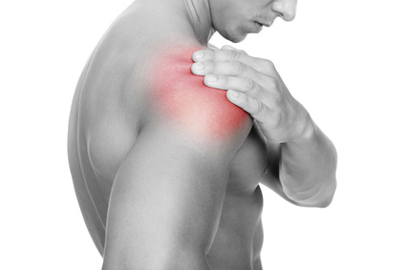**Date Location Duration Contact**

1-2 September Falkirk 2-days [www.vitalpm.com](http://www.vitalpm.com)

18-20 October London 2-days [www.vitalpm.com](http://www.vitalpm.com)

7-8 November Derby 2-days [iw@welbeing-cpd.com](mailto:iw@welbeing-cpd.com)

There are courses throughout Europe in 2019 and new UK dates for 2020– for a full course list contact jogibson1@live.co.uk

**E-learning**

The Shoulder: Steps To Success Online course in conjunction with Clinical Edge & David Pope (https://[www.clinicaledge.co](http://www.clinicaledge.co) ) is due to re-launch in November 2019. If you sign up to view the free assessment videos then you will be sent details automatically.