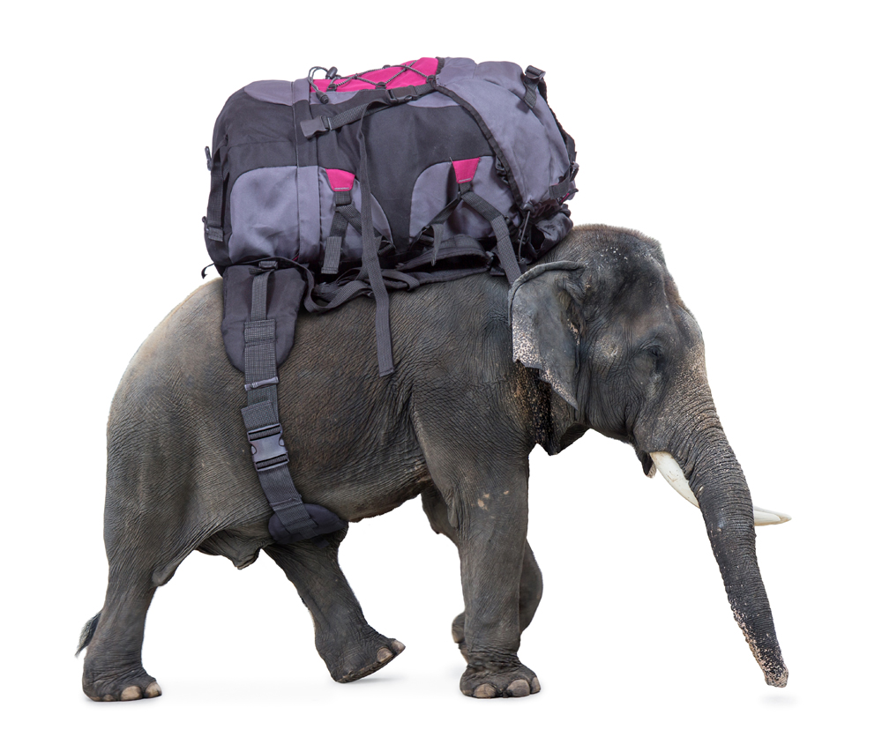**Bag or Backpack – which to choose and why!**



Sometimes, you feel like you have the weight of the world on your shoulders - but this shouldn’t be a reaction to the bag you are carrying!

Carrying something heavy puts a strain on your body: whether it’s a child, an armful of files, your laptop or a lump of concrete - the potential for pulled muscles and injury is high.

Did you know that a child’s bag should weigh approximately 10% of his or her bodyweight? Well, the same rough guide can be applied to adults! Unless you’re a trained weightlifter, try to pack essential items only, and remember that it’s better to make two trips to the car than to struggle with lots of heavy bags.

Thinking in advance about what you have to carry is a good idea. Do you really need all that stuff?! Could you take out some of the extra bits a pieces?

Of course, the type of bag you choose to carry can aggravate the problem. As you can imagine, a backpack is preferable to a bag with a single strap. This is because the weight is distributed more evenly. You can also help your back by packing the heaviest items into your bag first.

Adjustable straps on your bag are also important - the bag should rest firmly against the top of your spine, sitting above your buttocks. The back panel should also be padded, with a curved lower edge. If your bag has a waist strap, make use of it: it’s all very well looking stylish, but your body will thank you if you focus on good support.

Despite our best intentions, there are time when just have to carry loads that are too heavy for us. If you get injured this way just remember that you can always give an osteopath a call - we’ve got it in the bag!