

**Safeguarding Policy for COVID-19**

The aim of this document is to offer guidance to clinicians, cleaners, and administrative staff, as we prepare our centre to begin seeing COVID-19 patients. It includes guidance on the protective equipment and hygiene levels necessary to safeguard both patients and staff from infection, and the training advised by Public Health England to ensure the above.

***Disclaimer:*** *Evidence for COVID-19 is changing almost on a daily basis. It is essential to update this document as often as possible. Please highlight any evidence or points that may be subject to change.*

|  |  |
| --- | --- |
| **Company name** | Core Clapton |
| **Model policy number** | 001 |
| **Model policy name** | COVID-19 Safeguarding Policy |
| **Responsible person** | Daniel Orchard |
| **Date** | 4th May 2020 |

**Contributions by:**

Gabriel Antoni-Pineda

Pietro Bini

Benjamin East

Marina Antoni-Pineda

***Note to staff:*** *Please choose the appropriate self-assessment checklist from the table below, and review all sections relevant to your position (see* *Appendix 1* *for exemplar documents and* *Appendix 2* *for training resources).*

|  |  |
| --- | --- |
| **Administrative staff** | [Ancillary staff self-assessment checklist](https://forms.gle/Lp5Xdh8QgMnvDMcW7) |
| **Cleaning staff** | [Ancillary staff self-assessment checklist](https://forms.gle/Lp5Xdh8QgMnvDMcW7) |
| **Clinical staff** | [Clinical staff self-assessment checklist](https://forms.gle/KvGvhBkG13yjbrUE6) |

[**This document has been produced for the benefit of the osteopathic community. Please click to make a donation to support our work at Core Clapton (registered charity no. 1166246).**](https://www.justgiving.com/campaign/coreclapton)

**Background to the COVID-19 Pandemic**

The newly identified severe acute respiratory syndrome, coronavirus 2 (SARS-CoV-2), caused by the novel coronavirus 2019 disease (COVID-19), is of precedence due to the declaration of a [pandemic](https://www.who.int/dg/speeches/detail/who-director-general-s-opening-remarks-at-the-media-briefing-on-covid-19---11-march-2020) by the World Health Organisation on 11th March 2020 (Lai et al., 2020; Ghebreyesus, 2020).

It is currently understood that SARS-CoV-2 spreads mainly through the respiratory tract in the form of droplets (Guo et al., 2020; Sohrabi et al., 2020). Though most commonly spread through human-to-human contact, the virus has also been detected on surfaces for up to 72 hours after administration, particularly on plastic and stainless steel. In addition, SARS-CoV-2 showed an aerosol durability of at least three hours (van Doremalen et al., 2020). Both factors increase transmission. An individual may become infected by touching an object that contains SARS-CoV-2, then coming into contact with their respiratory tract (touching mouth, nose or eyes), or through the inhalation of SARS-CoV-2 particles in the air (Thomas et al., 2020).

Patients that test positive for COVID-19 present with a variety of symptoms; the majority experience ‘mild to moderate respiratory illness’ (WHO, 2020). The most prevalent symptom is fever, present in 88.7% of hospitalised patients, followed by a cough (67.8% of patients) (Guan et al., 2020). Other reported symptoms include fatigue (38%), sputum production (34%), shortness of breath (19%), and a sore throat (14%) (Ellison III et al., 2020; WHO, 2020). One study showed that 1.2% of individuals presented as asymptomatic (Liu Xing Bing Xue Za Zhi et al., 2020). It has been stated that 81% of cases are mild (patients do not present with pneumonia or mild pneumonia), 15% are severe (with pulmonary infiltrates in over 50% of patients within 24-48 hours, and requiring oxygen), and 5% of cases are critical (showing respiratory failure with requirements for ventilation). Fatality rate has been estimated as 2.3%, with an increase to 14% in patients aged 80 or above, increasing further to 49% in critical patients and in patients with preexisting comorbid conditions (Wu and McGoogan, 2020; Chang et al., 2020).

**Table of Contents**

**Preparing to Reopen the Clinic** **3**

Resource planning 3

Floor plans 3

Pre-opening training itinerary 4

**The Patient Journey: Standard Operating Procedure (SOP)** **5**

Screening Guidelines for COVID-19 Patients 6

**Understanding Infection Prevention and Control (IPC) Measures** **8**

Introduction to IPC measures 8

Ensuring triage, early recognition, and source control 8

Applying standard precautions for all patients 8

Hand hygiene 8

Implementing empiric additional precautions 9

**Understanding Personal Protective Equipment (PPE)** **10**

PPE summary 10

Materials needed for PPE (see Appendix 5 for Infographic) 11

Donning and doffing sequences 12

PPE and home visits 14

**Cleaning** **15**

Introduction to cleaning 15

Clinic room cleaning protocol 15

Handwashing protocol 16

Safe management of linen (laundry) 17

Staff uniforms/ clothing 17

Management of clinical and non-clinical waste 18

**Educating Patients and Caregivers** **19**

Patient education 19

Caregiver education 20

**Staff Wellbeing** **21**

Support yourself, support each other 21

Exposure of healthcare staff 21

Wellbeing advice for healthcare professionals 21

**Appendices** **22**

Appendix 1: Example self-assessment checklist for clinicians and staff. 22

Appendix 2: Training resources 24

Appendix 3: Remote triage and assessment 25

Appendix 4: COVID-19 in primary care 26

Appendix 5: A visual guide to safe PPE 27

**References** **28**

# **Preparing to Reopen the Clinic**

## **Resource planning**

The size of your clinic will determine the resources needed to ensure its safe opening. Here is a recommendation of the necessary levels of staffing and PPE, dependent on the size of your clinic.

|  |  |  |  |
| --- | --- | --- | --- |
| **Phase** | **Location** | **Staffing** | **Equipment needed** |
| Tier 1  (≤ 8 patients per day) | Clinic with at least 2 separate rooms, to follow IPC guidelines. | Minimal staff on site for emergency consultations.  1 Admin.  Cleaners working after patients if needed. | Minimal amount of PPE needed; remote consultations prioritised if appropriate. Clinic prepared following IPC guidelines. |
| Tier 2  (8 - 16 patients per day) | Clinic with 4 separate rooms. | Staffing may increase depending on patient numbers.  1 Admin.  Cleaners working after patients. | Greater amount of PPE may be needed depending on patient numbers. Remote consultations encouraged if appropriate. Clinic prepared following IPC guidelines. |
| Tier 3  (>20 patients per day) | Clinic with 4 separate isolation rooms, and 2 sections for infection control. | As above, and increased depending on patient numbers.  Cleaners working on site. | As above. |

## 

## **Floor plans**

Creating and following a floor plan will enable staff and patients to maintain social distancing measures in the clinic upon reopening.

The following is a clinic floor plan of Core Clapton. Note the clearly marked direction of flow, with entrances, exits, and doffing/ donning stations also clearly shown.

If possible, it is recommended to use a separate entrance and exit.

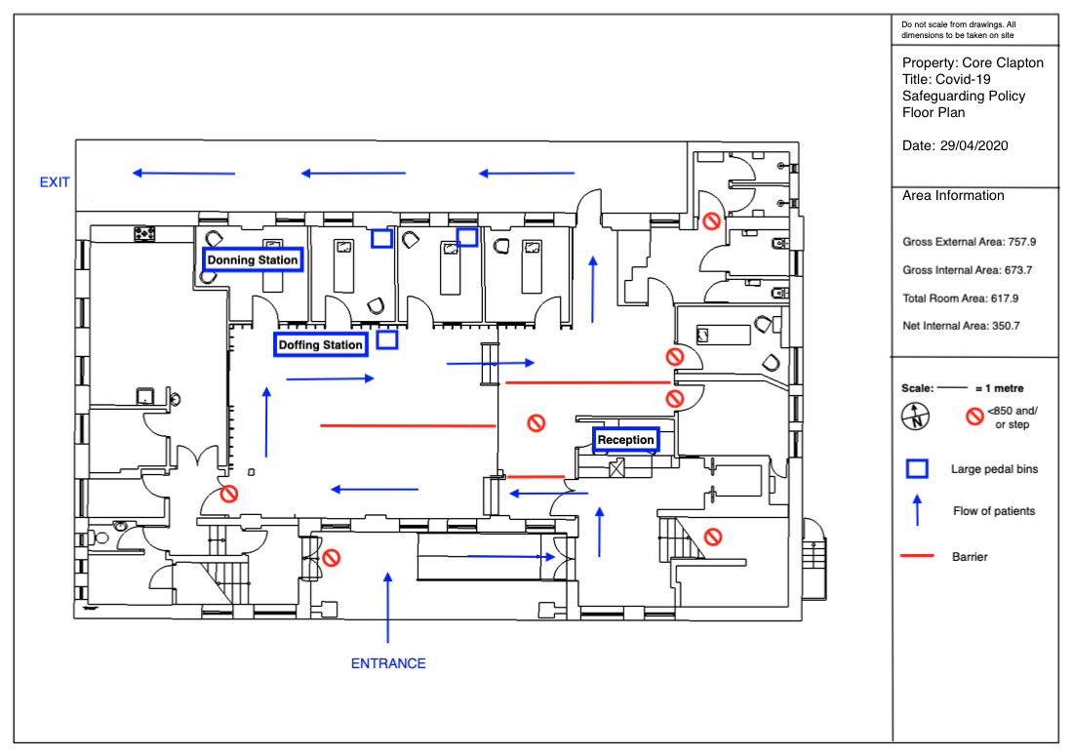

## **Pre-opening training itinerary**

[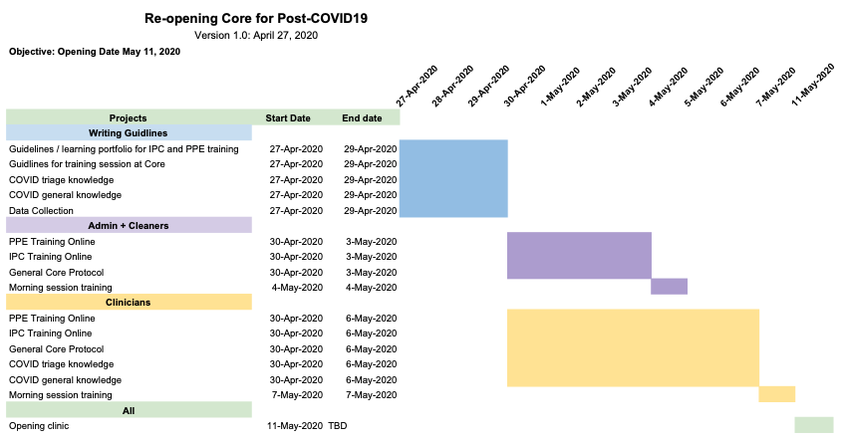](https://docs.google.com/spreadsheets/d/1-eID13yiAvP5fIYxy3f4HjRYLpengCW1ZpXmSjdI_9o/edit?usp=sharing)

# **The Patient Journey: Standard Operating Procedure (SOP)**

The following is a suggested series of steps that may be taken to ensure correct social distancing, infection prevention, and the maintenance of control during a patient’s visit to the clinic.

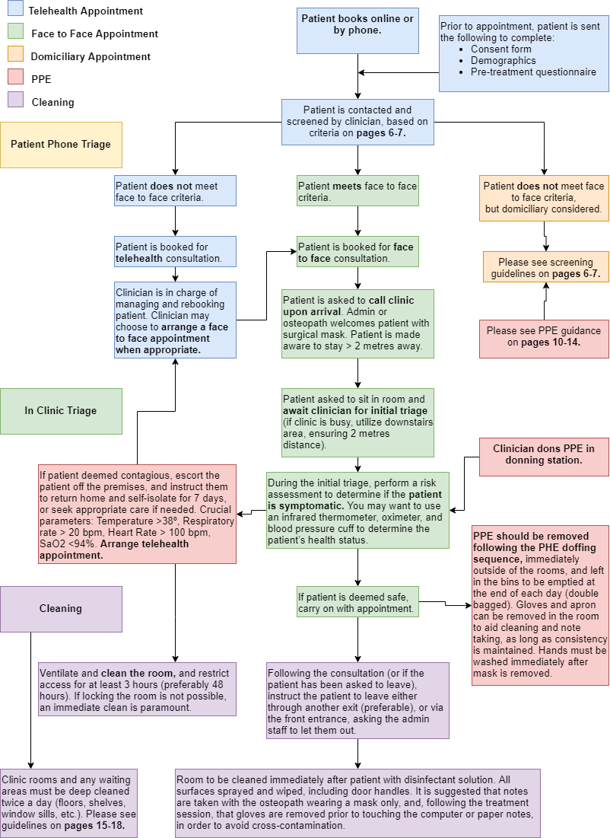

## **Screening Guidelines for COVID-19 Patients**

(CDC.gov recommendations; Greenhalgh et al., 2020)

The minimisation of the number of patients who may still be contagious is essential to ensure a prevention of spread. See Appendix 3 and Appendix 4 for how to triage remotely and in the clinic.

The main symptoms of coronavirus are (WHO.int, Global surveillance for human infection with COVID-19):

* a high temperature (>37.8°)
* a new, continuous cough

**Box 1: Pre-Treatment Screening Questionnaire**

|  |
| --- |
| 1. Have you had close contact with or cared for someone diagnosed with COVID-19 within the last 14 days? Yes / No 2. Have you experienced any cold or flu-like symptoms in the last 14 days (to include fever, cough, sore throat, respiratory illness, difficulty breathing)? Yes / No |

**Box 2: Procedure for assessing health status of patient (for clinicians)**

|  |
| --- |
| During the initial triage perform a risk assessment to determine if the patient is symptomatic. You may want to use an infrared thermometer, oximeter and blood pressure cuff to determine the patient’s health status.    **Why do we perform a risk assessment?**  The risk assessment will give you guidance if someone should seek medical attention and/or the extent of Post-COVID-19 pulmonary lesions.    **Parameters:**  Temperature >37.8°, Respiratory rate >20 breaths pm, Heart rate >100 beats pm, O2 saturation <94% (risk assess for 90-94%). |

Screening patients will minimize COVID-19 exposure and ensure safety to those who belong in the high-risk group. Patients can be split into 5 main groups:

**Group 1:** Patients presenting with mild respiratory dysfunction and/or MSK dysfunctions post-COVID-19 infection

**Group 2:** Patients currently symptomatic or positive with COVID-19, mild or severe.

**Group 3:** High risk patients, not symptomatic

**Group 4:** Patients not at risk and not symptomatic with need for emergency care

**Group 5:** Patient without need for emergency care

NB. High risk patients are those 65 years older, having undergone organ transplantation, certain treatments of cancer, certain respiratory and heart conditions, pregnant women with significant heart disease, immunocompromised, diabetes, chronic kidney and liver disease (This list is not exhaustive) (CDC, 2020).

**The following table outlines the different pathways of care for each category of patient:**

|  |  |
| --- | --- |
| **Symptoms, risk, and need for care assessment** | **Action required** |
| **Group 1:** No fever and improvement of other COVID-19-related symptoms in the last >72 hours, COVID-19 symptoms development >7 days prior to contacting the clinic and/or 2 negative COVID-19 tests 24 hours apart NOT belonging to high-risk category AND with need for emergency care. | Educate and offer remote consultation if possible.  **Arrange face-to-face appointments** and follow IPC and PPE protocol. |
| **Group 2a:** Mild fever, cough or shortness of breath AND/OR having been in contact with a suspected or confirmed COVID-19 case in the last 14 days. | Recommend to self-isolate. Educate but DO NOT offer thoracic mobility prehabilitation.  **Offer remote consultation** and check on symptoms in 12-24 hours .  Only under extreme circumstances offer **home visit** with adequate PPE protocol. |
| **Group 2b:** Severe and deteriorating cough, shortness of breath, fever AND/OR difficulty breathing, persistent chest pain, new confusion, central cyanosis, cold and mottled skin, difficult to rouse, decreased urinary output, neck stiffness, non-blanching rash. Crucial parameters if patients have equipment: temperature >38°, Respiratory rate >20 bpm, Heart rate >100 bpm, O2 saturation <94%. | **Refer to emergency services.** If this is impossible, arrange follow up by video for symptoms monitoring. Only under extreme circumstances offer home visit with adequate PPE protocol. |
| **Group 3:** No current COVID-19-related symptoms, no contact with suspected or confirmed COVID-19 cases in the last 14 days BUT belonging to high-risk category. | Recommend to self-isolate. Educate and explain thoracic mobility prehabilitation. **Offer remote consultation** if possible.  Only under extreme circumstances offer **home visit** with adequate PPE protocol. |
| **Group 4:** No current COVID-19-related symptoms, no contact with suspected or confirmed COVID-19 cases in the last 14 days, not belonging to high-risk category WITH need for emergency face to face consultation (i.e. ICU-AW, post-operative, urgent MSK problem or respiratory deficits also post COVID-19). | **Arrange face-to-face appointments**. Educate and offer telemedicine if possible. Required to follow IPC and PPE protocol. |
| **Group 5:** No current COVID-19-related symptoms, no contact with suspected or confirmed COVID-19 cases in the last 14 days, not belonging to high-risk category WITHOUT need for emergency face to face consultation. | Recommend to keep isolating. Educate and explain thoracic mobility prehabilitation.  **Offer remote consultation.** |

# **Understanding Infection Prevention and Control (IPC) Measures**

All staff must complete NHS IPC courses (see Appendix 2) to inform themselves of current best practice in the prevention and control of infection.

## **Introduction to IPC measures**

These IPC measures are primarily based on the latest update of the ECDC Technical Report (ECDC, 2020), and WHO Interim Guidance (WHO, 2020). Both documents provide an evidence-based set of technical measures and resources aimed at limiting the spread of COVID-19 in healthcare settings.

## **Ensuring triage, early recognition, and source control**

(WHO, 2020)

* Health Care Workers (HCW) should have a high level of clinical suspicion during phone and face-to-face triaging;
* Establishing a well-equipped triage station at the entrance to the facility, supported by trained staff;
* Using screening questionnaires according to the updated case definition.
* Posting signs in public areas reminding symptomatic patients to alert HCWs.

Hand hygiene and respiratory hygiene are essential preventive measures.

## **Applying standard precautions for all patients**

(WHO, 2020)

Standard precautions include hand and respiratory hygiene, the use of appropriate PPE according to a risk assessment, safe waste management, proper linens, environmental cleaning, and sterilization of patient-care equipment.

* Ensure that all patients cover their nose and mouth with a tissue or elbow when coughing or sneezing;
* Offer a medical mask to patients with suspected COVID-19 while they are in waiting/public areas or in cohorting rooms;
* Perform hand hygiene after contact with respiratory secretions.

## **Hand hygiene**

HCWs should apply WHO’s My 5 Moments for Hand Hygiene approach before (1) touching a patient, (2) before any clean or aseptic procedure is performed, (3) after exposure to body fluid, (4) after touching a patient, and (5) after touching a patient’s surroundings.

* Hand hygiene includes either cleansing hands with an alcohol-based hand rub or with soap and water;
* Alcohol-based hand rubs are preferred if hands are not visibly soiled;
* Wash hands with soap and water when they are visibly soiled.

## **Implementing empiric additional precautions**

**Contact and droplet precautions**

(WHO, 2020)

* HCWs should follow guidelines in the following section on PPE;
* Equipment should be either single-use and disposable or dedicated equipment (e.g. stethoscopes, blood pressure cuffs and thermometers). If equipment needs to be shared among patients, clean and disinfect it between use for each individual patient (e.g. by using ethyl alcohol 70%);
* HCWs should refrain from touching eyes, nose, or mouth with potentially contaminated gloves or bare hands;
* Where possible, a specific HCW should be designated to care exclusively for suspected or confirmed cases to reduce the risk of transmission;

**Airborne precautions for aerosol-generating procedures (AGPs)**

(WHO, 2020)

Aerosol generating procedures (AGPs) create an airborne risk of transmission of COVID-19. The following AGPs are taken as example from physiotherapy guidelines and include:

* Cough generating procedures e.g. a cough during treatment, a huff;
* Positioning / gravity assisted drainage techniques and manual techniques (e.g. expiratory vibrations, percussion, manual assisted cough) that may trigger a cough and the expectoration of sputum;
* Manual hyperinflation (MHI);
* Inspiratory muscle training;
* Sputum inductions;
* Any mobilisation or therapy that may result in coughing and expectoration of mucus.

(N.B. It is not clear which osteopathic techniques are AGPs at this moment in time but likely examples would be; supine thoracic HVT, upper rib sternal thrusts, any exercise that gets the patient out of breath, deep breathing techniques.)

If it is deemed essential, and cannot be performed in another manner (ie. prone, from behind etc), ensure the following precautions are taken:

* Perform procedures in an adequately ventilated room – that is, natural ventilation with good air-flow;
* Use a particulate respirator at least as protective as a FFP2, or equivalent. When HCWs put on a disposable particulate respirator, they must always perform the seal check. Note that facial hair (e.g. a beard) may prevent a proper respirator fit;
* Use eye protection (i.e. goggles or a face shield);
* Wear a clean, non-sterile, long-sleeved gown and gloves. If gowns are not fluid-resistant, HCWs should use a waterproof apron for procedures expected to create high volumes of fluid that might penetrate the gown;
* Limit the number of persons present in the room to the absolute minimum required for the patient’s care and support.

# **Understanding Personal Protective Equipment (PPE)**

All staff must complete NHS PPE courses (see Appendix 2: Training resources) to inform themselves of current best practice in the wearing of personal protective equipment.

## **PPE summary**

Before undertaking any procedure, staff will need to assess any likely exposure, and ensure PPE is worn. This must provide adequate protection against the risks associated with the procedure or task being undertaken. All staff should be trained in the proper use of all PPE that they may be required to wear.

All PPE should be:

* Located close to the point of use;
* Stored to prevent contamination in a clean/dry area until required for use (expiry dates must be adhered to);
* Single-use only;
* Changed immediately after each patient and/or following completion of a procedure or task;
* Disposed of after use into the correct waste stream i.e. healthcare/clinical waste (this may require disposal via orange or yellow bag waste; local guidance will be provided depending on the impact of the disease).

HCW less than 2 metres away but not involved with AGPs should wear the following:

* Fluid resistant surgical mask
* Gloves
* Disposable plastic aprons
* Risk assessment for eye protection

Any technique which induces a cough and/or increases respiratory rate is considered aerosol generating procedures (AGPs). Therefore, any HCW involved with patient rehabilitation should assume full AGP-required-PPE (within <2m) even if patient status is not confirmed as a COVID-19 case (Thomas et al., 2020):

* FFP3/N95 mask
* Fluid resistant gown
* Eye protection
* Gloves

## **Materials needed for PPE (see** **Appendix 5 for Infographic****)**

**Mask**

Fluid resistant surgical masks are adequate for most osteopathic consultations. If every patient is wearing a mask then these can potentially be for sessional use (risk to be assessed on a case by case basis). Otherwise single use is suggested.

FFP3 or N95 masks are to be used when performing AGPs. All respirators should:

* Be well fitted, covering both nose and mouth;
* Not be allowed to dangle around the neck and to be reused;
* Not to be touched once put on;
* To be removed outside patient room;
* Fit tested for the relevant model to ensure adequate seal (All facial hair must be removed).

**Apron/ gown**

Disposable plastic aprons must be worn to protect staff uniforms or clothes from contamination when providing direct patient care and during environmental and equipment decontamination.

Fluid-resistant gowns must be worn when a disposable plastic apron provides inadequate cover of staff uniform or clothes for the procedure/task being performed and when there is a risk of extensive splashing of blood and/or other body fluids e.g. during AGPs. If non fluid-resistant gowns are used, a disposable plastic apron should be worn underneath.

Disposable aprons and gowns must be changed between patients and immediately after completion of a procedure/task.

**Disposable gloves**

Disposable gloves must be worn when providing direct patient care and when exposure to blood and/or other body fluids is anticipated/likely, including during equipment and environmental decontamination. Gloves must be changed immediately following the care episode or the task undertaken.

**Eye protection/ face visor**

Eye/ face protection should be worn when there is a risk of contamination to the eyes from splashing of secretions (including respiratory secretions), blood, body fluids or secretions. An individual risk assessment should be carried out prior to/at the time of providing care. Disposable, single-use, eye/face protection is recommended. Regular corrective spectacles are not considered adequate eye protection.

Eye/ face protection can be achieved by the use of any one of the following:

* surgical mask with integrated visor;
* full face shield/visor;
* polycarbonate safety spectacles or equivalent.

## **Donning and doffing sequences**

The order in which you put on (donning) or remove (doffing) your personal protective equipment is essential for protecting yourself and preventing the spread of any possible contaminants or fluids.

The following is the correct sequence for **donning** your PPE:

1. Gown or apron;
2. Mask or respirator;
3. Goggles or face shields;
4. Gloves.

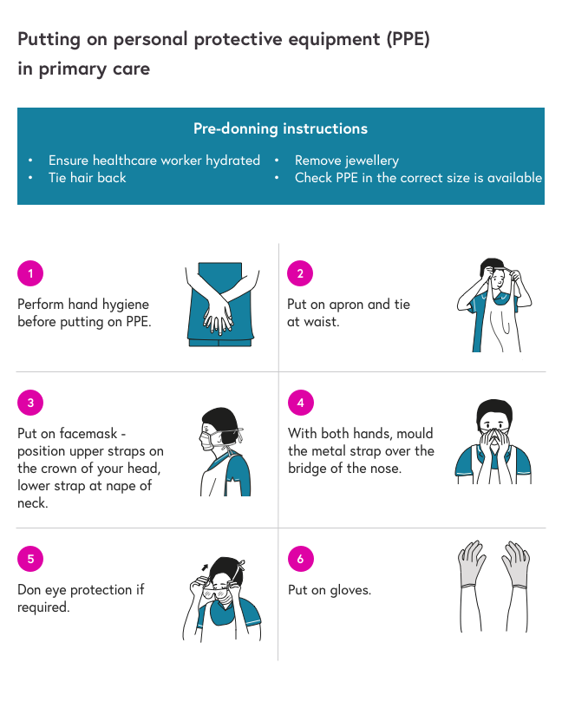

It is extremely important to take great care when removing and disposing of used PPE to avoid exposure to infection. It is important to practice before using these techniques in a clinical setting, ideally with a colleague to provide guidance and feedback.

The following is the correct sequence for **doffing** your PPE:

1. Gloves;
2. Face shield or goggles;
3. Gown;
4. Mask or respirator.
5. Hand hygiene.

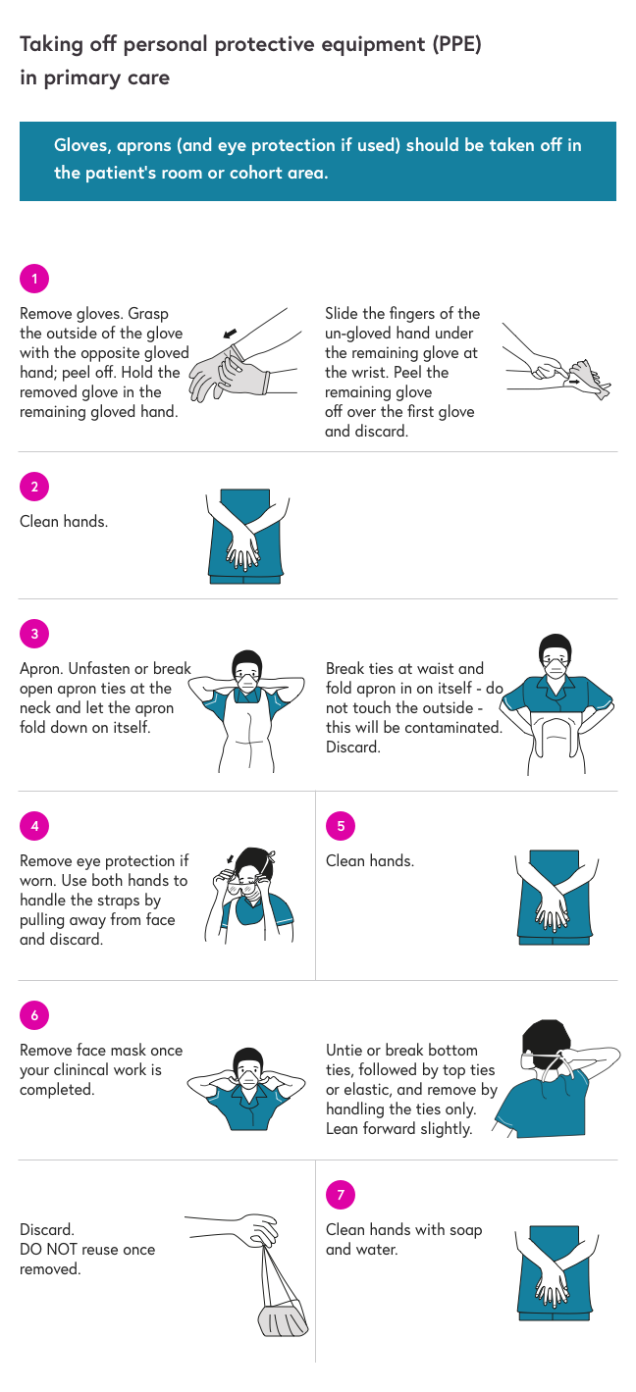

The sequence for removing PPE is intended to limit opportunities for self-contamination. The gloves are considered the most contaminated pieces of PPE and are therefore removed first.

## **PPE and home visits**

(Professional practice guidance for home visits during COVID-19 Pandemic, 2020)

Planning a visit:

* Use clinical judgment to weigh pros and cons of visit;
* Explain to the patient risks of home visit;
* Using the guidelines plan the visit with the patient.

Immediately before the visit:

* Assume same PPE guidance as mentioned above (mask for both patient and practitioner);
* If soap is not available, utilize hand gel the same way you would practice hand hygiene in clinic;
* Ensure that you have a place to dispose of the PPE after the visit (eg. black plastic bags);
* Explain to patient the reasons behind PPE, and how you will minimize the risks;
* Confirm who is in the house and health status;
* Explain again how you are following public health guidelines to minimize the risk;
* Ask patient to open a window to allow for air circulation.

During the visit:

* If possible, without touching anything and keeping >2 meter distance have the direct use to a sink with soap for hand hygiene;
* Apply PPE immediately following donning guidance;
* If this is not possible, use hand gel instead and apply PPE before entering home;
* During visit, minimize the surfaces touched;
* Minimize time spent at the home.

After the visit:

* Sanitise reusable equipment that you have brought into the home;
* Dispose of any non reusable equipment;
* Following doffing guidance remove PPE and take back to clinic for storing before disposing;
* Perform hand hygiene;
* Ask patient to open the door for you and leave home without touching anything and keeping a 2 metre distance;
* Re-sanitise using hand gel if necessary.

# **Cleaning**

(ECDC, 2020)

## **Introduction to cleaning**

The clinic must be thoroughly cleaned before reopening, and again at frequent intervals once open.

* Regular cleaning is followed by disinfection, using hospital disinfectants active against viruses.
* If there is a shortage of hospital disinfectants, decontamination may be performed with 0.1% sodium hypochlorite (dilution 1:50, if household bleach at an initial concentration of 5% is used) after cleaning with a neutral detergent.
* Surfaces that may become damaged by sodium hypochlorite may be cleaned with a neutral detergent, followed by a 70% concentration of ethanol.

Staff engaged in environmental cleaning and waste management should wear appropriate PPE. If there is an insufficient stock of respirators, then a surgical mask may be worn, as well as gloves, goggles and gown. In addition, the use of heavy-duty gloves and boots should be considered.

## **Clinic room cleaning protocol**

The following diagram highlights the key areas to address during both frequent and deep cleans of the clinic rooms.

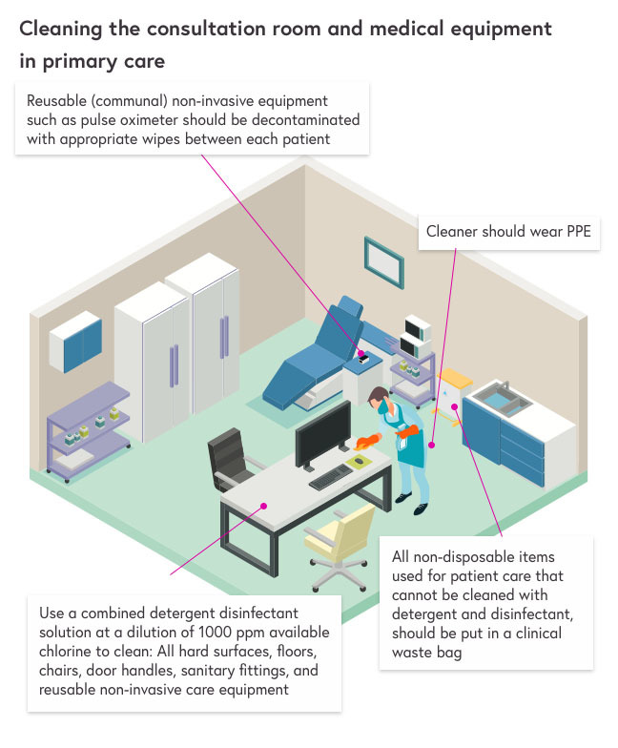

## **Handwashing protocol**

(WHO, 2020)

Clean your hands regularly, for at least 20 seconds.

* Hand hygiene includes either cleansing hands with an alcohol-based hand rub or with soap and water;
* Alcohol-based hand rubs are preferred if hands are not visibly soiled;
* Wash hands with soap and water when they are visibly soiled.

For HCW-specific information on handwashing, please see Hand hygiene.

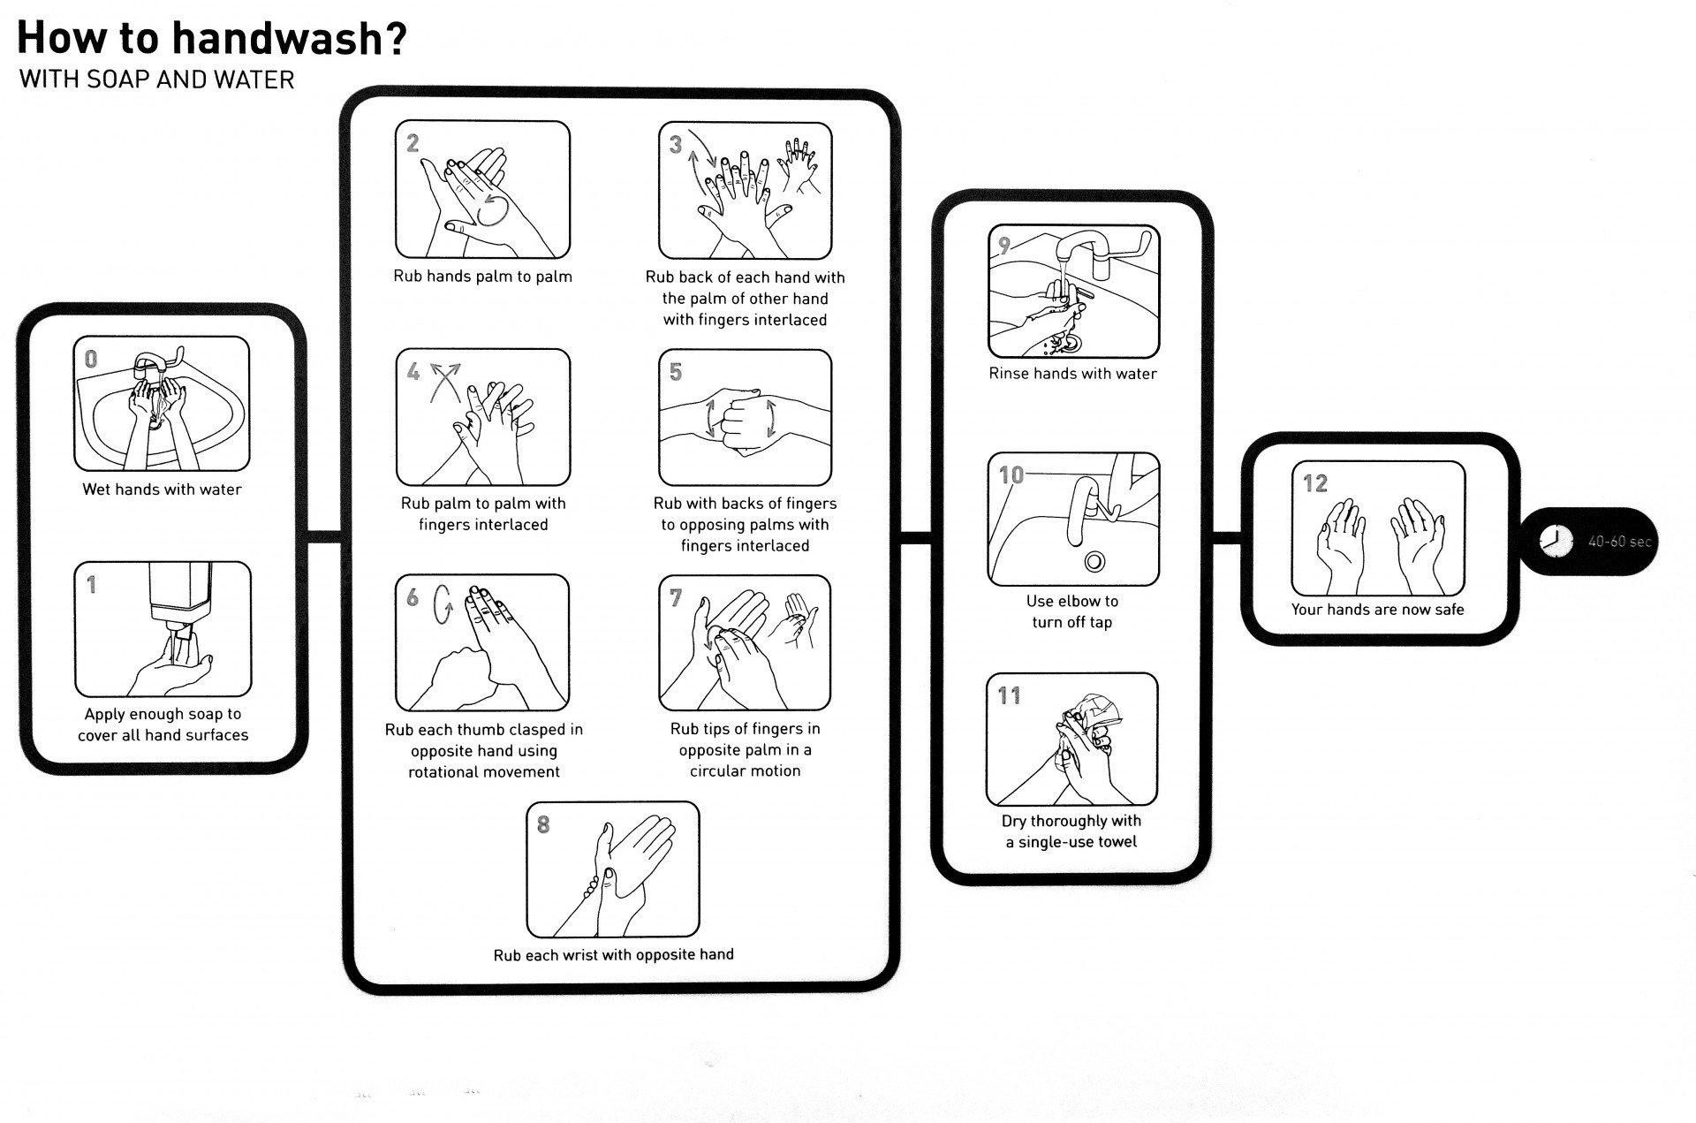

# 

# 

# 

# 

# 

## **Safe management of linen (laundry)**

No special procedures are required, but linen is categorised as ‘used’ or ‘infectious’. All linen used in the direct care of patients with suspected and confirmed COVID-19 should be managed as ‘infectious’ linen. Linen must be handled, transported and processed in a manner that prevents exposure to the skin and mucous membranes of staff, contamination of their clothing and the environment:

Disposable gloves and an apron should be worn when handling infectious linen.

All linen should be handled inside the patient room/cohort area. A laundry receptacle should be available as close as possible to the point of use for immediate linen deposit.

When handling linen, **do not**:

* Rinse, shake or sort linen on removal from beds/trolleys;
* Place used/infectious linen on the floor or any other surfaces e.g. a locker/table top;
* Re-handle used/infectious linen once bagged;
* Overfill laundry receptacles; or
* Place inappropriate items in the laundry receptacle e.g. used equipment/needles.

When managing infectious linen, **do**:

* Place directly into a water-soluble/alginate bag and secure;
* Place the water-soluble bag inside a clear polythene bag and secure;
* Place the polythene bag into the appropriately coloured (as per local policy) linen bag (hamper).

All linen bags and receptacles must be tagged, e.g. clinic/ care area and date. Store all used or infectious linen in a designated, safe, lockable area whilst awaiting uplift. Organisational preparedness plans should consider the safe storage of excess linen awaiting collection and for maintaining supplies of clean linen for patient use.

## **Staff uniforms/ clothing**

The appropriate use of PPE will protect staff uniforms from contamination in most circumstances. Changing rooms, or areas where staff can change into uniforms on arrival at work, should be provided. Theatre scrubs, or similar, should be considered for staff who do not usually wear a uniform but who are likely to come into close contact with patients.

Uniforms should be transported home in a disposable plastic bag. This bag should be disposed of into the household waste stream.

Uniforms should be laundered:

* Separately from other household linen;
* In a load not more than half the machine capacity;
* At the maximum temperature the fabric can tolerate, then ironed or tumbled-dried.

N.B. It is best practice to change into and out of uniforms at work, and not wear them when travelling. This is based on public perception, rather than evidence of an infection risk.

## **Management of clinical and non-clinical waste**

Large volumes of waste may be generated by frequent use of PPE; advice from the local waste management team should be sought prospectively on how to manage this. Dispose of all waste as clinical waste.

Disposal of all waste related to possible or confirmed cases should be classified as infectious clinical waste suitable for alternative treatment. It is suggested that all clinical waste should be double bagged before being stored for a minimum of 3 days. For large clinics with commercial bins on a weekly collection, bins could be rotated to minimise risk to bin collectors.

# 

# **Educating Patients and Caregivers**

Patients and their caregivers may be unsure of how to behave whilst directly affected by COVID-19. The following information may be recommended to patients and their caregivers when necessary.

## **Patient education**

(CDC, 2020)

In case a patient is showing mild respiratory signs and symptoms, they should be recommended to stick to the following instructions during isolation:

* Stay at home;
* Stay in touch with their doctor and monitor their symptoms, making sure to get care in case of worsening of the symptoms or development of other respiratory symptoms (i.e. severe and deteriorating cough, shortness of breath, fever >38°, difficulty breathing, persistent chest pain, new confusion, central cyanosis, cold and mottled skin, difficult to rouse, decreased urinary output, neck stiffness, non-blanching rash, respiratory rate >20apm, heart rate >100bpm, O2 saturation <94%);
* Avoid public transport;
* Stay away from others (even using a personal “sick room” if possible, staying away from relatives and pets until symptoms resolution);
* Call ahead before visiting any healthcare facility;
* Wear a surgical mask or a cloth face covering;
* Cover their sneezes and coughs with their elbow or tissues (to be disposed immediately)
* Wash their hands for at least 20’’, especially after:

blowing their nose, coughing, sneezing, going to the toilet, eating and preparing food;

* Use hand sanitizer with >60% alcohol if soap or water are not available;
* Avoid to touch the T-zone (eyes, nose and mouth);
* Avoid sharing personal household items, washing thoroughly after use;
* Clean and disinfect the “sick room” everyday, letting a caregiver clean the rest of the house;
* Focus the cleaning on “high-touch surfaces” (i.e. phones, remote controls, door knobs, toilets, keyboards, bedside tables);

Isolation should be ceased when:

* Not experiencing fever for >72 hours AND other symptoms have improved AND at least 7 days have passed since the symptoms were developed (if not tested for COVID-19)
* Not experiencing fever for >72 hours AND other symptoms have improved AND they received 2 negative tests 24 hours apart (if tested for COVID-19)

## 

## **Caregiver education**

(CDC, 2020)

Caregivers should:

* Monitor the symptoms of the person cared for and know the emergency warning signs;
* Always have their healthcare provider contact on hand and contact them or 999 for medical emergencies;
* Isolate the symptomatic person to one room, if possible, using a separate bathroom and not using household items;
* Have them wearing a cloth face covering when other people (including the caregiver) are around;
* Wear a cloth face covering if the symptomatic person cannot do so;
* Wash their hands for at least 20 seconds, especially after interacting with the symptomatic person, using hand sanitizer if soap and water are not available;
* Avoid touching the T-zone;
* Clean “high touch surfaces” daily;
* Wash laundry thoroughly, wearing disposable gloves if the laundry is soiled, washing hands immediately after gloves removal;
* Avoid unnecessary visitors;
* Make sure the sick person drinks plenty of fluid;
* Providing recommended medicines;
* Follow the same home isolation-ending measures as the sick person.

# 

# **Staff Wellbeing**

(Extracted from *FutureLearn* course [Managing COVID-19 in General Practice](https://www.futurelearn.com/courses/managing-covid-19-in-primary-care))

## **Support yourself, support each other**

In these challenging times, it’s very important that we work to maintain both our own wellbeing and the wellbeing of our colleagues. Healthcare workers face a number of risks to their physical and mental health, so we need to provide support and help to each other, so that we are able to continue to care for our patients effectively.

It is very valuable to debrief with the practice team regularly, especially those who are directly involved in patient management.

Identify vulnerable healthcare workers, such as pregnant or immunosuppressed individuals, and move them to non-patient facing roles. Seek advice from the occupational health service if available.

## **Exposure of healthcare staff**

If a member of staff develops a fever of >37.8°C, shows respiratory symptoms, or lives in the same household as a person with symptoms, they should follow the local policy for testing and self-isolation.

Frontline staff are at increased risk of physical and mental health problems during the COVID-19 pandemic because of working in extremely challenging circumstances.

## **Wellbeing advice for healthcare professionals**

* Talk to your friends and family and stay connected with them.
* Seek help from your colleagues, supervisor and practice manager.
* Turn to your peers and share your thoughts and feelings and listen to theirs.
* Take regular breaks and try to reduce your screen time.
* Avoid watching, reading or listening to the news that could cause you to feel anxious or distressed and seek information updates at specific times.
* Ensure you have time to wind down after work and get a good night’s sleep.
* Stay well-hydrated and eat healthily by planning your meals and taking your time to enjoy your meals.
* Try to reduce your intake of alcohol and caffeine.
* Try a free wellbeing class or app.
* For further tips and advice please visit the World Health Organisations (WHO) website.
  + [Mental health and psychosocial considerations during the COVID-19 outbreak](https://www.who.int/docs/default-source/coronaviruse/mental-health-considerations.pdf)
  + [Stay physically active during self-quarantine](http://www.euro.who.int/en/health-topics/health-emergencies/coronavirus-covid-19/novel-coronavirus-2019-ncov-technical-guidance/stay-physically-active-during-self-quarantine)

# **Appendices**

## **Appendix 1: Example self-assessment checklist for clinicians and staff.**

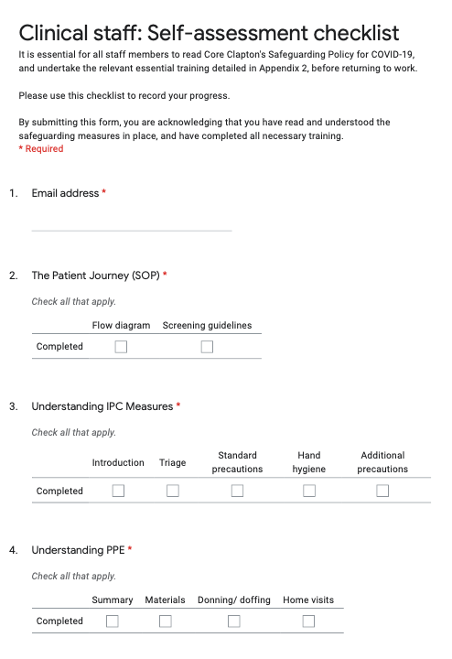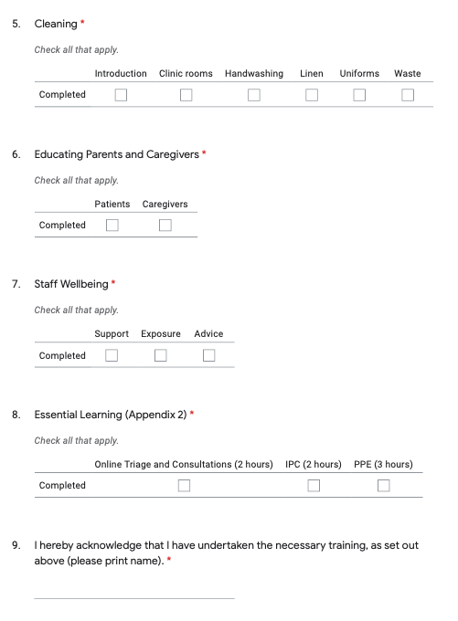

## 

## **Appendix 2: Training resources**

The following table contains the most up to date links to training resources, and suggested hours needed to complete them.

**Please USE and KEEP this resource to help your return as a clinician. Please also sign and date each topic to show that you have completed the necessary modules before returning to work.**

|  |  |  |  |  |
| --- | --- | --- | --- | --- |
| **Importance** | **Subject** | **Resources** | **Time** | **Sign/Date** |
| Essential Learning | Online Triage and Consultations | [Moving to online triage and consultations, NHS England](https://www.youtube.com/watch?v=sczwFG6fxZM&t=1276s)  [Remote Total Triage Model in General Practice, HEE](https://portal.e-lfh.org.uk/LearningContent/LaunchForGuestAccess/609561) | 2 hours |  |
| IPC | [NHS Coronavirus Infection Control](https://www.england.nhs.uk/coronavirus/primary-care/infection-control/)    [COVID-19: Infection Prevention and Control Guidelines](https://www.gov.uk/government/publications/wuhan-novel-coronavirus-infection-prevention-and-control) | 2 hours |  |
| PPE | [Donning of PPE, Public Health England](https://www.youtube.com/watch?v=kKz_vNGsNhc&t=196s)  [Removal and Disposal of PPE, Public Health England](https://www.youtube.com/watch?v=oUo5O1JmLH0)  [Public Health England PPE Guidance](https://www.gov.uk/government/publications/wuhan-novel-coronavirus-infection-prevention-and-control/covid-19-personal-protective-equipment-ppe) | 3 hours |  |
| Suggested Reading | Useful learning resources | [A remote assessment in primary care. Published on March 25, 2020](https://www.bmj.com/content/368/bmj.m1182)  [Understanding Coronavirus Disease, Physiopedia](https://members.physio-pedia.com/learn/understanding-coronavirus-disease-covid-19/) |  |  |
| Useful websites | [NCOR: Management of COVID-19 symptoms at home: a compilation of advice. Published March 30, 2020](https://www.ncor.org.uk/news/management-of-covid-19-symptoms-at-home-a-compilation-of-advice/)  [Institute of Osteopathy COVID-19 FAQs](https://www.iosteopathy.org/covid-19/faq/) |  |  |

HEE = Health Education England IPC = Infection Prevention Control

PPE = Personal Protection Equipment PHE = Public Health England

## 

## **Appendix 3: Remote triage and assessment**

## **Appendix 4: COVID-19 in primary care**

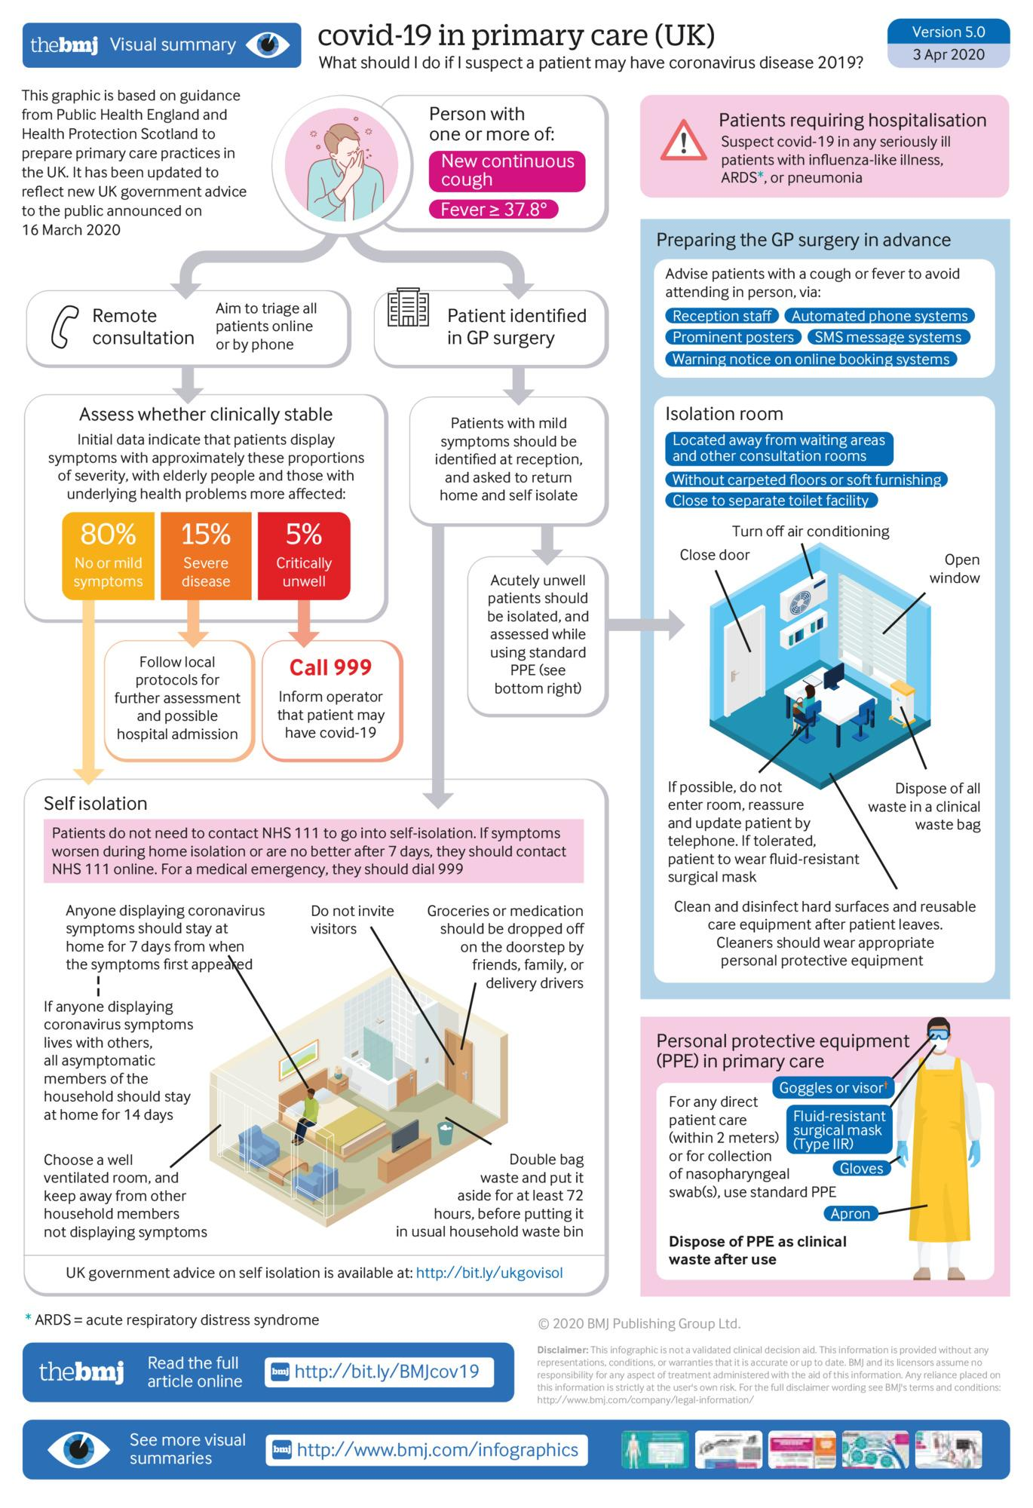

## **Appendix 5: A visual guide to safe PPE**

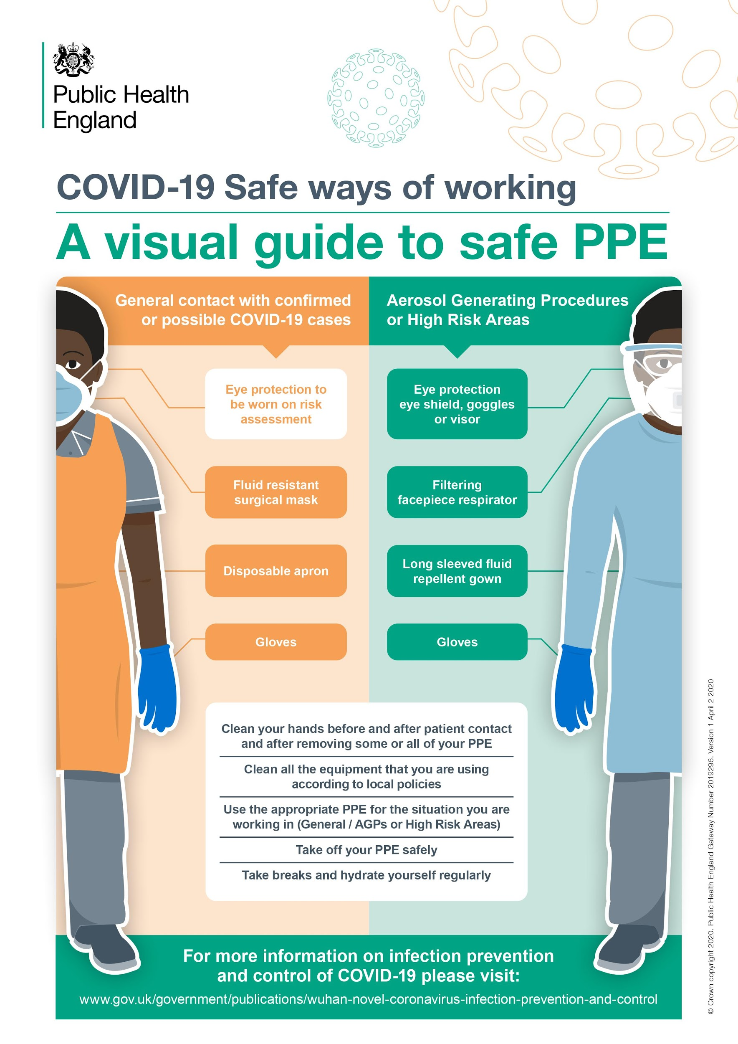

# **References**

1. BASW. 2020. *Professional Practice Guidance For Home Visits During Covid-19 Pandemic*. [online] Available at: <https://www.basw.co.uk/professional-practice-guidance-home-visits-during-covid-19-pandemic> [Accessed 8 April 2020].
2. Centers for Disease Control and Prevention. 2020. Coronavirus Disease 2019 (COVID-19). [online] Available at: <https://www.cdc.gov/coronavirus/2019-ncov/if-you-are-sick/care-for-someone.html> [Accessed 7 April 2020].
3. Centers for Disease Control and Prevention. 2020. Coronavirus Disease 2019 (COVID-19). [online] Available at: <https://www.cdc.gov/coronavirus/2019-ncov/if-you-are-sick/steps-when-sick.html> [Accessed 7 April 2020].
4. Centers for Disease Control and Prevention. 2020. Coronavirus Disease 2019 (COVID-19). [online] Available at: <https://www.cdc.gov/coronavirus/2019-ncov/need-extra-precautions/groups-at-higher-risk.html> [Accessed 8 April 2020].
5. Centers for Disease Control and Prevention. 2020. Symptoms Of Coronavirus. [online] Available at: <https://www.cdc.gov/coronavirus/2019-ncov/symptoms-testing/symptoms.html> [Accessed 6 April 2020].
6. Chang, D., Lin, M., Wei, L., Xie, L., Zhu, G., Dela Cruz, C. and Sharma, L., 2020. Epidemiologic and Clinical Characteristics of Novel Coronavirus Infections Involving 13 Patients Outside Wuhan, China. *JAMA*, [online] 323(11), p.1092. Available at: <https://jamanetwork.com/journals/jama/fullarticle/2761043> [Accessed 6 April 2020].
7. Ellison III, R., 2020. *NEJM Journal Watch: Summaries Of And Commentary On Original Medical And Scientific Articles From Key Medical Journals*. [online] Jwatch.org. Available at: <https://www.jwatch.org/na51039/2020/03/04/update-clinical-characteristics-covid-19> [Accessed 7 April 2020].
8. European Centre for Disease Prevention and Control. 2020. *Infection Prevention And Control And Preparedness For COVID-19 In Healthcare Settings - Second Update*. [online] Available at: <https://www.ecdc.europa.eu/en/publications-data/infection-prevention-and-control-and-preparedness-covid-19-healthcare-settings#no-link> [Accessed 7 April 2020].
9. FutureLearn. 2020. Managing COVID-19 In General Practice - Online Course - Futurelearn. [online] Available at: <https://www.futurelearn.com/courses/managing-covid-19-in-primary-care> [Accessed 5 May 2020].
10. Ghebreyesus, T., 2020. *WHO Director-General's Opening Remarks At The Media Briefing On COVID-19 - 11 March 2020*. [online] Who.int. Available at: <https://www.who.int/dg/speeches/detail/who-director-general-s-opening-remarks-at-the-media-briefing-on-covid-19---11-march-2020> [Accessed 7 April 2020].
11. GOV.UK. 2020. *COVID-19 Personal Protective Equipment (PPE)*. [online] Available at: <https://www.gov.uk/government/publications/wuhan-novel-coronavirus-infection-prevention-and-control/covid-19-personal-protective-equipment-ppe> [Accessed 9 April 2020].
12. GOV.UK. 2020. *COVID-19: Infection Prevention And Control (IPC)*. [online] Available at: <https://www.gov.uk/government/publications/wuhan-novel-coronavirus-infection-prevention-and-control> [Accessed 7 April 2020].
13. Greenhalgh, T., Koh, G. and Car, J., 2020. Covid-19: a remote assessment in primary care. BMJ, [online] Available at: <https://www.bmj.com/content/bmj/368/bmj.m1182.full.pdf> [Accessed 6 April 2020].
14. Guan, W., Ni, Z., Hu, Y., et al., 2020. Clinical Characteristics of Coronavirus Disease 2019 in China. *New England Journal of Medicine*, [online] Available at: <https://www.nejm.org/doi/10.1056/NEJMoa2002032> [Accessed 7 April 2020].
15. Guo, Y., Cao, Q., Hong, Z., et al., 2020. The origin, transmission and clinical therapies on coronavirus disease 2019 (COVID-19) outbreak – an update on the status. *Military Medical Research*, [online] 7(1). Available at: <https://mmrjournal.biomedcentral.com/articles/10.1186/s40779-020-00240-0> [Accessed 7 April 2020].
16. Health Education England. 2020. *Allied Health Professions*. [online] Available at: <https://www.hee.nhs.uk/our-work/allied-health-professions> [Accessed 7 April 2020].
17. Kmietowicz, Z., 2020. Covid-19: Highest risk patients are asked to stay at home for 12 weeks. BMJ,.
18. Lai, C., Shih, T., Ko, W., Tang, H. and Hsueh, P., 2020. Severe acute respiratory syndrome coronavirus 2 (SARS-CoV-2) and coronavirus disease-2019 (COVID-19): The epidemic and the challenges. *International Journal of Antimicrobial Agents*, [online] 55(3), p.105924. Available at: <https://pubmed.ncbi.nlm.nih.gov/32081636/> [Accessed 6 April 2020].
19. Liu xing bing xue za zhi, Z., 2020. The Epidemiological Characteristics of an Outbreak of 2019 Novel Coronavirus Diseases (COVID-19) in China. *Advance online publication.*, [online] 41,2, pp.145-151. Available at: <http://rs.yiigle.com/yufabiao/1181998.htm> [Accessed 7 April 2020].
20. Physiopedia. 2020. *Personal Protective Equipment (PPE)*. [online] Available at: <https://physio-pedia.com/Personal_Protective_Equipment_(PPE)#ppm29849> [Accessed 7 April 2020].
21. Physiopedia. 2020. *Role Of The Physiotherapist In COVID-19*. [online] Available at: <https://www.physio-pedia.com/Role_of_the_Physiotherapist_in_COVID-19#ppm30048> [Accessed 7 April 2020].
22. Physiopedia. 2020. Role Of The Physiotherapist In COVID-19. [online] Available at: <https://www.physio-pedia.com/Role_of_the_Physiotherapist_in_COVID-19#ppm30048> [Accessed 7 April 2020].
23. ReliefWeb. 2020. Infection Prevention And Control And Preparedness For COVID-19 In Healthcare Settings. [online] Available at: <https://reliefweb.int/report/world/infection-prevention-and-control-and-preparedness-covid-19-healthcare-settings-third> [Accessed 7 April 2020].
24. Sohrabi, C., Alsafi, Z., O'Neill, N., Khan, M., Kerwan, A., Al-Jabir, A., Iosifidis, C. and Agha, R., 2020. World Health Organization declares global emergency: A review of the 2019 novel coronavirus (COVID-19). *International Journal of Surgery*, [online] 76, pp.71-76. Available at: <https://www.sciencedirect.com/science/article/pii/S1743919120301977?via%3Dihub> [Accessed 7 April 2020].
25. Thomas, P., Baldwin, C., Bisset, B., et al., 2020. Physiotherapy Management for COVID-19 in the Acute Hospital Setting: Recommendations to guide clinical practice. *Journal-of-physiotherapy*, [online] Available at: <https://physiotherapy.ca/sites/default/files/final_physiotherapy_guideline_covid-19_v1_dated23march2020_endorsed730am.pdf?fbclid=IwAR32kMc_IKqWCHxekfzVe-i2e65xItZrEaBa4AIMHy3DIEeUPnH7JRVZygs> [Accessed 6 April 2020].
26. van Doremalen, N., Bushmaker, T., Morris, D., et alV., 2020. Aerosol and Surface Stability of SARS-CoV-2 as Compared with SARS-CoV-1. *New England Journal of Medicine*, [online] Available at: <https://www.ncbi.nlm.nih.gov/pubmed/32182409> [Accessed 6 April 2020].
27. Who.int. 2020. *Coronavirus Disease 2019 (COVID-19) Situation Report -76*. [online] Available at: <https://www.who.int/docs/default-source/coronaviruse/situation-reports/20200405-sitrep-76-covid-19.pdf?sfvrsn=6ecf0977_2> [Accessed 6 April 2020].
28. World Health Organization. 2020. Infection Prevention And Control During Health Care When Novel Coronavirus (Ncov) Infection Is Suspected. [online] Available at: <https://www.who.int/publications-detail/infection-prevention-and-control-during-health-care-when-novel-coronavirus-(ncov)-infection-is-suspected-20200125> [Accessed 7 April 2020].
29. World Health Organization. 2020. *Personal Protective Equipment*. [online] Available at: <https://www.who.int/medical_devices/meddev_ppe/en/> [Accessed 7 April 2020].
30. Wu, Z. and McGoogan, J., 2020. Characteristics of and Important Lessons From the Coronavirus Disease 2019 (COVID-19) Outbreak in China. *JAMA*, 323(13), p.1239.