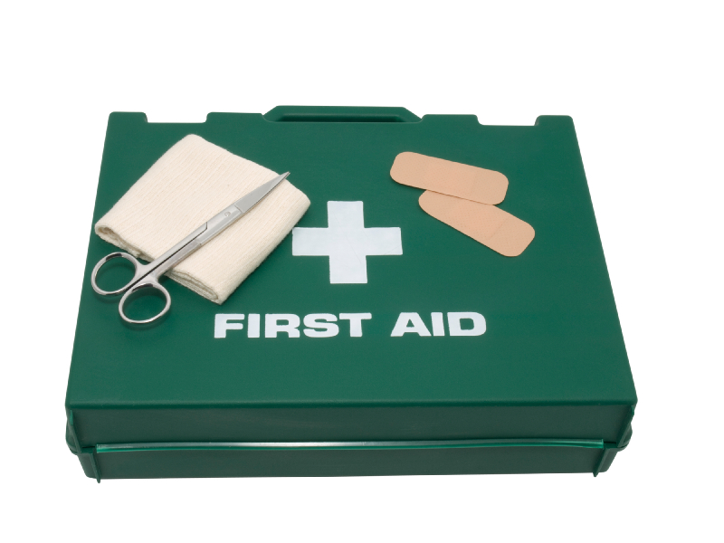**First Aid Kits**

Search online for a first aid kit and you’ll find plenty on offer, often claiming that they are compliant with “British Standard BS8599-1…” or “HSE Statutory Requirements”. Some even have “deluxe” cases(!).

So how do you know what’s appropriate for you, either at work, at home, or in the car?

To get the detailed answer to that you’d have to delve into the *Health and Safety at Work etc Act 1974\** and nobody would want to inflict that on you.

So here’s the simple answer.

You only need a kit that meets British Standards (set by the British Standards Institute) if you want to achieve ISO 9000 certification. **You are really unlikely to need this** unless you are a business tendering to an organisation which demands it.

****There is no “Statutory Requirement”** in the UK for the contents of a first aid kit. The HSE merely gives a list of suggested contents, but emphasises that what goes in the box should be based on your risk assessment.

Now, if you’re operating a small business, you probably can’t be bothered to carry out a first aid risk assessment, so you just buy an off-the-shelf kit from an online organisation. That’s definitely the easiest way to comply with the law.

Interesting though that an HSE recognised first aid qualification (the contents of this ARE legally stipulated) insists that you learn mouth-to-mouth resuscitation (rescue breaths), how to deal with burns, and how to remove small splinters.

But their list of first aid kit contents does **NOT** include face shields, burn dressings or tweezers! They do include 6 safety pins, despite the fact that nobody can come up with a good reason.

My view is that you are very unlikely ever to need to use your first aid kit other than for sticking plasters. But when you do need it, you want the right things in there.

If you have a kettle, then a burn dressing is a good idea (they cost about £2.00). Tweezers cost a couple of quid. Face shields cost only a few pence, and they’re small enough to fit in your purse, wallet or pocket (trust me – if you ever have to give rescue breaths, you’ll be very glad of one!).

So, by all means go for one of the off-the-shelf kits, but have a think about the other useful items you might add. One day you might be glad you did!

Oh, and don’t bother with “deluxe cases” – just make sure your kit is clearly marked and everyone knows where it is.

*\* Yes, that really is what it’s called – even the “etcetera”!*