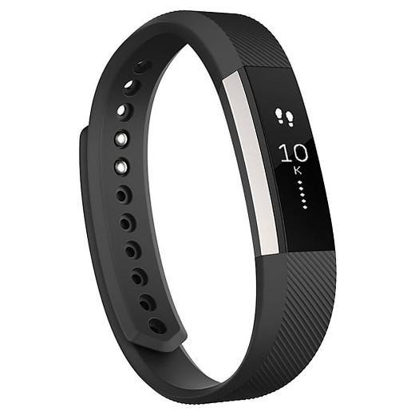**Fitbit Sleep Monitoring**

More and more of my patients these days are wearing “Fitbits” or the equivalent (“Fitbit” now seems to be the generic term for any wrist-worn activity monitor, a bit like “Hoover”*).

I don’t have one myself, but I was intrigued by the manufacturers’ claims that they can measure the quality of sleep. This is something we’re all interested in, and the notions of “clean sleep” and “sleep hygiene” are very much on trend at the moment.

So I was very interested to listen to Dr Neil Stanley, talking about the science of sleep to The Academy of Physical Medicine recently. Dr Stanley is hugely knowledgeable on this topic, having set up what was the largest sleep research facility in Europe at the University of Surrey.

His answer regarding Fitbits (and all the other similar devices)? They do NOT give any meaningful data on the quality of your sleep. That doesn’t mean they can’t count your daily footsteps, or measure the calories you burn, but when it comes to sleep, they’re hopelessly inaccurate (35% at best). This is hardly surprising, given the complexity of measuring the different stages of sleep, which can only be done accurately by monitoring brain activity.

This doesn’t mean that activity monitors are useless, of course. The very fact that they incentivise us to do more exercise is a great thing, and it’s possible that the other measurements they provide are more accurate.

But bear in mind this comment by Dr Stanley: worrying about the quality of sleep is the thing that causes most of the problems! He did some serious, research-based guidance on getting good sleep, and if you’d like more information, feel free to get in touch.

*\* Just to be absolutely clear: Hoovers don’t measure your sleep quality and aren’t usually worn on the wrist. However, they may contribute to your 10,000 steps per day…*