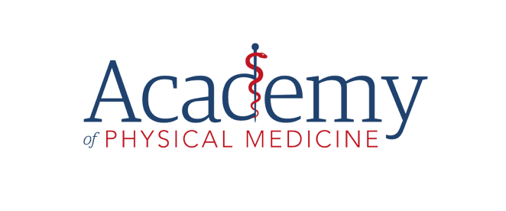**GDPR Approaches:**

***Some Ideas***

One of the thorny problems under this new-fangled GDPR is the issue of getting consent.

If consent is needed (and I said “if”, notice), then it has to be explicit, freely given yada yada yada. What that means is, if they do not tick your consent box, or if they don’t reply to your email asking for consent, you have to assume that they did NOT consent. Which is a shame, because 89.7%[1] of people will take the easiest option, which is to DO NOTHING.

And that means, after May 25th, you mustn’t process their data – in other words, no communication.

So, given that we aren’t generally trying to flog PPI or double glazing, we need to find a way to encourage our patients to allow us to send stuff to them. Because we all know that building a relationship is the best way to keep your patients loyal to you, and to promote the healthy living which they all seek.

First things first: This has nothing to do with taking a case history, storing the case history or sending out appointment reminders. It is APM’s opinion (for all the reasons given in our other documents) that you do not need consent for any of these. We are talking here about consent for you to send material which does not relate directly to the patient’s health problem, or to an enquiry they might otherwise have made.

Second, one of the “Lawful Reasons” to process a person’s data is “**Legitimate Interest**”. If this applies, then you do not need consent. The Institute of Osteopathy recently engaged a consultant to deliver advice on the GDPR, and he was emphatic that Legitimate Interest was sufficient justification for you to send things like newsletters, promotions, general health tips and so on.

**We do not accept that advice**. Reading the GDPR and the ICO guidance indicates that these would fall outside the scope of Legitimate Interest (unless your newsletter/health tips actually included something which relating to the patient’s problem – hard to ensure in a mass mail-out). But it’s up to you whether you go with his opinion – it’s certainly the easy way out.

Legitimate Interest is, even according to the ICO itself, a very grey area. And the fact remains that hardly anyone is likely to complain provided they have the option to opt out of your mailing list. **So the risk you run is very, very small indeed**.

However, if you decide that you should get consent before you send marketing/relationship building information, then you’ll want to do it in a way that encourages people to take action (because doing nothing, counts as not giving consent).

Here are some ideas you could use to galvanise people into action:

1. Word your question in such a way that it emphasises what your patient will miss out on.
2. Do NOT ask them to consent to receive your newsletter. Nobody wants to receive a newsletter!
3. 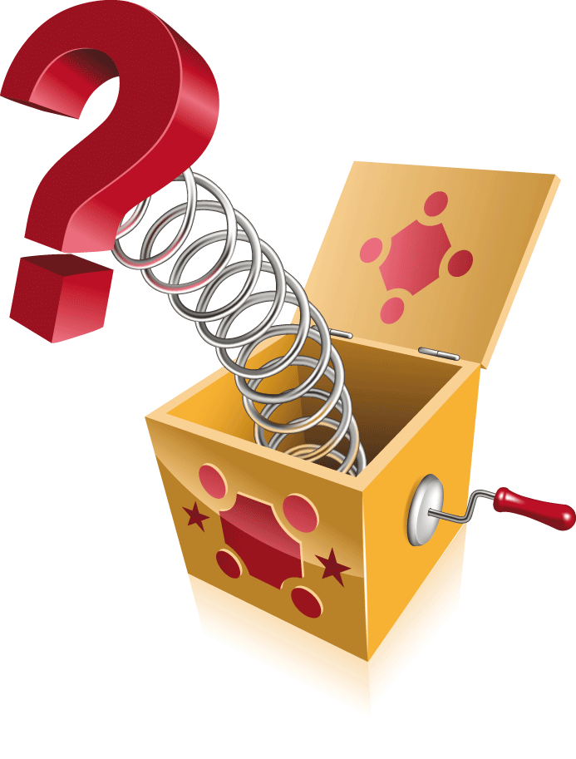Have a “radio button” form, where they have to select either yes or no. This will only work on paper forms or on a webform, but it means they will actually have to do something, so if they tick “No”, you can be sure that’s what they meant. And don’t worry about the people who do tick the “No” box. They don’t want your emails, so you’ve lost nothing by removing them from your mailing list.
4. To drive a response from an email, you could offer to enter them into a draw. Make it really attractive – it won’t cost the Earth, because there’s only one prize. And don’t exclude people who say no. It’s a bit of a grey area again, but the GDPR implies that you can’t incentivise people to say yes (specifically, it says that you cannot deny them a service, or deliver a lesser service for not opting in). Plenty of people will assume anyway that saying yes gets them a better chance of the prize!
5. Having said earlier that you do not need consent to take or store a medical record, you could nonetheless use this to drive a response. We’re into another grey area, but you could say that you want to cover yourself under the new law, and need their consent to “process their data”. That could encompass taking a history, storing the record and sending newsletters - the full detail would be in your Privacy Notice. Very few will bother to look, and in any case, you’ll always give them the opportunity to opt out from marketing communications. This one is likely to drive a response from patients who think they are likely to return to you at some point, but as with all things, it won’t get a 100% return.

Overleaf are a few ideas on emails you might want to send. My firm belief is that you are more likely to get a response if these demonstrate your personality. Think of all the GDPR compliance messages you have received recently – how excited were you about reading them?

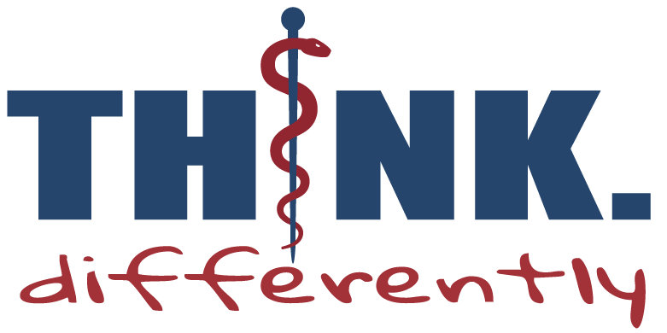**Email Ideas**

**Notes**:

* Feel free to use these drafts to stimulate your own creative flow. Most of them are quite light-hearted, but you can change the tone completely if you don’t communicate with your patients in that way.
* Remember, the most important thing is to keep the subject box and the first two lines (the ones you see in the email preview) really interesting, so that people actually open your messages.
* If you aren’t able to insert buttons in your messages, just ask them to click reply and type “yes” in the email.
* Remember to personalise your messages - put “Dear …..” at the beginning.
* Send them from a named account if you can – not “admin@...”
* Sign off with your name.
* Make messages personal to your clinic, staff, dog, sport etc so it means something special to your patients when they receive it.
* Buy the chocolate buttons and leave them in the clinic – just for fun!

**Email 1**

Subject:  I need your help!

I’ve been told I can’t talk to you any more!

My health updates, offers and all the fantastic stuff we have going on at ******** - all the stuff I like to tell you about your joints, fitness and ****** (alongside news about the dogs/kids/rugby/cats/baking…, of course!)

I can no longer do this unless you click the button below to confirm that you want them.

I really hope you want to continue getting my news and offers - we’ve got a new member of the team starting soon/some fun Summer offers/a charity cake sale/a new back pain blog post/new info on pillows coming up, so there are lots of reasons to click the button!

And **** is happening too! There’s always so much going on here – why would you not click the button?!

As always, thanks so much for all the lovely people you refer to the clinic/us/me.  We’ve had some great results with shoulder pain recently, and it’s just incredible to see our new patients improve so much.

Wishing you a great, and pain-free week

*******

**PS  Remember, if you don’t tick the box you’re going to miss out on a lot of information which will help keep you (and your family) healthy**

**PPS Stop reading this email and click the button!**

**Email 2**

Subject: Don’t leave me!

I don’t want you to leave me. But it may come to that. Ultimately the choice will be yours, or course, but I’m hoping you won’t go.

If you got my last email and forgot to hit reply you’ll never get another health update again. You’ll never know whether the latest pillow is better than Christmas pudding, nor how to work out whether your car seat is set up correctly.

If you want these fun-filled updates on how to stay fit, healthy and out of my treatment room just click reply/the button and I’ll make sure you get them.

In the meantime, remember that it’s fine to have a variety of pillows and to change them sometimes – there’s no rule to say that one pillow will suit you every single night!

**PS Click the button!!**

**Email 3**

Subject: Did you see it…?

Did you see my email with the buttons? No, not chocolate buttons! Though you may find a few of those in the clinic this week.

There’s been a mad panic recently about whether I can email you or not. It seems that the answer is no, I can’t.

At least, not unless you click the button here:

The new data protection rules state that you have to actively ask for my fabulous emails – the ones that are full of offers, news and clever tricks to help you stay healthy.

So, it’s simple; if you want to keep getting my clever health tricks click the button.

And while you’re trying to decide whether to click the button or not, here’s my top tip for this month: if you’re starting to venture out into the garden after all those months of rain, remember that prolonged periods of stretching forwards (weeding, potting out, hedge cutting) can really aggravate low back pain. Take short breaks to let your muscles have a rest!

Have a good week!

**PS Click the box! Click the box!**

**Email 4**

Subject: Please would you help keep me out of the wotsit…

I’m under quite a bit of stress at the moment with stuff I don’t fully understand thanks to the new government/EU regulations. If you have (literally) 10 seconds you could help me avoid getting into trouble.

It’s all about “processing your personal data” – I need to make sure I’m doing it legally.

Sounds daft, I know, considering I’m your osteopath / chiropractor / physiotherapist, but the aim is to protect you, and in particular, your medical records, which are subject to particularly stringent rules.

All you need to do is to reply with the word “YES” in the subject line/click this button and I can relax!

You can see what “processing your data” means by taking a look at my Privacy Policy (link) if you wish.

Thanks in advance – this would be a real help to keep my records in order!

**Other subject line ideas:**

Have you seen what they’ve done?

You won’t believe this!

Please help me!

Don’t leave me! (Openly pinched from another osteopath who shared her email in the #osteopathyworks FB Group)

I’m not allowed to talk to you!

I’ve been told to stop!

Don’t go! Please.

1. *Yeah, yeah – completely made up statistic!*