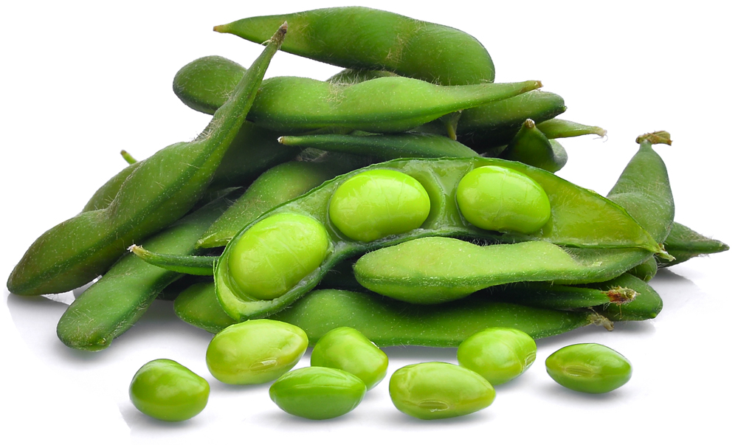**Hormone Replacement Therapy**

The progesterone component of HRT causes a (slight) increased risk of breast cancer. That said, it is very useful in combatting the other consequences of the menopause, in particular the weakened bones caused by osteoporosis.

So are there any realistic alternatives, that have less risk?

Well, I watched consultant gnaecologist Nitu Bajekal (co-founder of Women for Women’s Health (WfWH)), being interviewed by The Academy of Physical Medicine last week. I was really intrigued by her comments about the benefits of phytoestrogens, which are oestrogens found naturally in plants, notably soy. Flax seeds, berries, kidney beans, cereals, tofu all contain phytoestrogens, but the healthiest source is the edamame beans (soy beans still in the pod). These are great for salads and are popular among vegans because they are packed with low-fat soy protein.

And the great thing is – you can’t eat too much plant-based phytoestrogen. Any excess will be excreted naturally (unlike oestrogen from dairy sources).

So Dr Bajekal says eat lots of phytoestrogens: they great for menopausal symptoms, inhibit progression of breast cancer, and promote better bone mass.

However, it is worth mentioning that 90% of the soy sources we have now are genetically modified and are therefore potentially very unhealthy. The key is - any soy that is organically grown and fermented provides the healthiest phytoestrogen.

So for any woman – whether pregnant, lactating, menopausal, or having other issues with health - do make dietary choices accordingly. Incorporate real food into your diet and think about phytoestrogen supplements.

And medical HRT? Well, Dr Bajekal again recommends dietary and lifestyle changes first and foremost, but if your quality of life is affected enough, and you can’t make those changes then fine – just be aware of the risks!