**Finding your perfect heel height**

Have you ever wondered why some women adore sky-high heels, whilst others consider them a torture? The mystery can be solved with a closer look at the shape of your foot.

Statistics suggest that many women aren’t making the right choice for their feet when it comes to shoes. According to the College of Podiatry this causes the average woman 23 days of pain per year. The consequences of this aren’t just limited to pain - sore muscles, corns and blisters are also a risk, as well as the potential for long-term knee and back injury.

So, how do you choose what’s best for your feet?

Podiatrist Emma Supple says that a series of measurements can determine your perfect heel height, and allow you to walk in comfort. First, take off your shoes, sit down, and hold one leg in front of you with your foot relaxed. If your foot sits naturally at a right angle to your leg (without dangling), then you have less mobility in the talus (a curved bone that sits over the foot, connecting to the leg), and will be more comfortable in flat shoes. If the top of your foot falls forwards, you are a natural heel wearer!

To find your optimum heel height, ask a friend to stretch the tape measure from your heel, in a straight line parallel to the floor, then place a pencil at the ball of your foot (at a right angle to the tape). Reading the tape measure where it hits the pencil will give you your ideal heel height.

However, Emma does suggest a maximum height, not recommending more than three inches for day-to-day wear. Even if your ideal is higher, the height is likely to impact posture, so your body is thrown backwards. Sticking your bottom out will risk lower back pain- and, if the heel of the shoe is not directly under the heel bone, you won’t have maximum stability.

Ladies, when you next decide to buy a pair of shoes- grab a tape measure, and put your best foot forward!

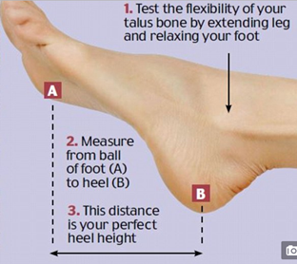

**References:**

1. <http://www.dailymail.co.uk/femail/article-3824090/There-formula-finding-heels-won-t-cripple-s-remarkably-simple.html>
2. <http://www.alterationsneeded.com/2015/03/how-to-measure-your-ideal-heel-height.html>