

**Emergency First Aid**

*With Steven Bruce and Malcom Parnell*

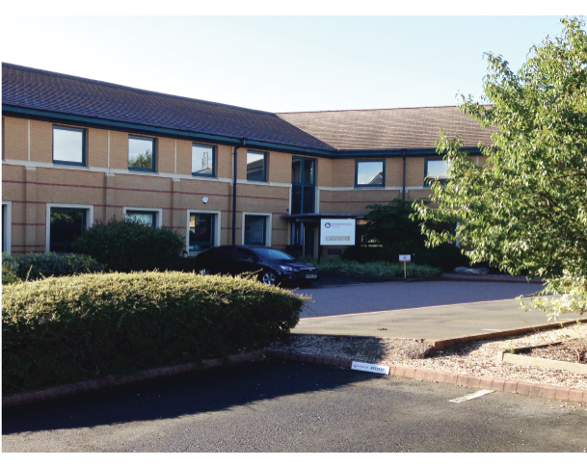

18th February

2018

EC Training Academy

2635 Kings Court

The Crescent

Birmingham Business Park

B37 7YE

***Congratulations*** on securing your place on Emergency First Aid in Clinic workshop being held on the 18th February. This will be a really valuable training day with Steven Bruce and Malcom Parnell, instructors with real-world experience.

***The When and Where***

The course will take place at the :

EC Training Academy

2635 Kings Court

The Crescent

Birmingham Business Park

B37 7YE

When you arrive: Go to the main entrance and follow the signposts (or ask at the reception desk). Tea and coffee will be available on arrival.

***By Road***

##### The EC Training Academy is close to Birmingham's NEC and situated within minutes of the M6/M42 junction, the venue is easily accessible by car, with rail and air terminals only a short distance away.

***Timings***

The course will run from 9.00am to 5.00pm.

***What to Bring***

The usual stuff for a practical course: comfortable clothing and a good sense of humour, we provide all the equipment you will need to practice your first aid skills.

***Sustenance***

Teas, coffees and biscuits will be provided on arrival and at morning and afternoon breaks.

Lunch is included in the course fee - if you have any dietary requirements please let us know well in advance and we will ensure your needs are met.

***And Finally...***

If you have any questions, don’t hesitate to give us a ring on:

**01933 328150**

On the day, please contact Steven’s mobile:

**07730 949440**

I’ll remind him to turn it off silent!!

It will be a great day and we look forward to seeing you there.

Best wishes,



Academy of Physical Medicine

Direct Line: 01933 328154

