**Certificate of Attendance**

**& Receipt**

|  |
| --- |
| Participant’s Name: |
|  |
| Course Title: |
| **Barral's visceral:**  **the intervertebral disc in focus** |
| Lecturer: |
| **Jean-Pierre Barral** |
| Course Date: |
| **7-9 Dec 2022** |
| Total Hours: |
| 20 |
| Total Paid:  £785.00 |
|  |

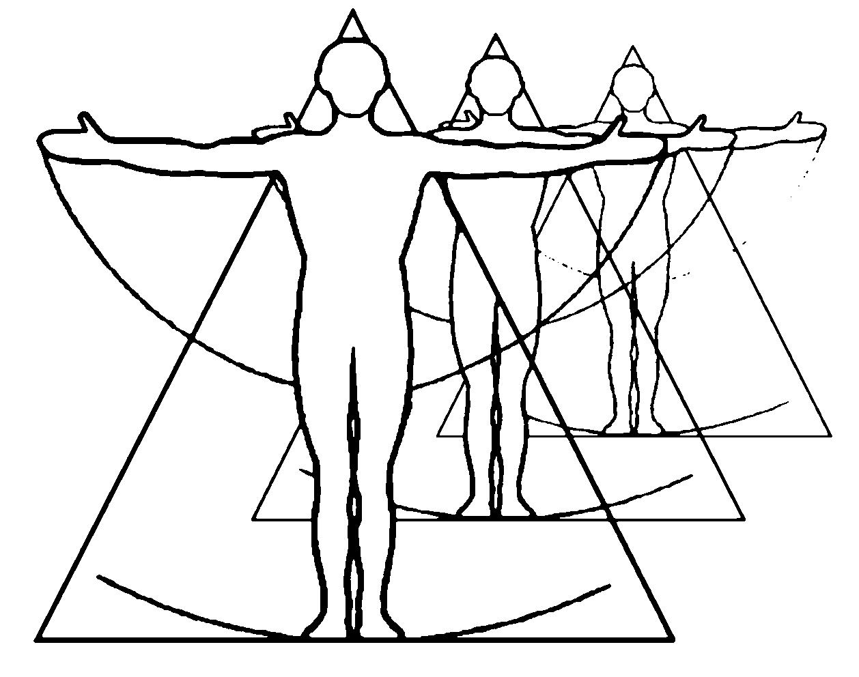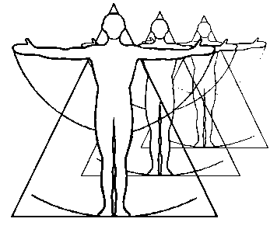

CPDO Ltd

Professional Development for Manual and Physical Therapists

www.cpdo.net / cpd@cpdo.net

15 Harberton Road, London N19 3JS, UK / Tel: 0044 207 263 8551

Dr. Eyal Lederman DO, PhD



Director, CPDO Ltd.

Date: 9/12/22